Official Use Only
Provisional Accredited Researcher Access Declaration
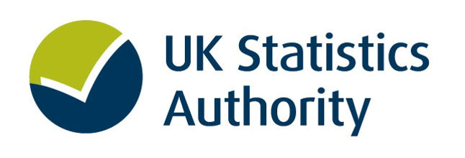

Access to de-identified personal information as a Provisional Accredited Researcher is conditional upon both the researcher and their Supervising Accredited Researcher signing this Declaration.

By signing this declaration, I confirm that:

- Information I provide in support of an application for access to personal information is true and accurate.
- I agree to my name, organisation and a summary of my Accredited Research project being published as required by the Digital Economy Act 2017 unless the UK Statistics Authority (the Authority) agrees otherwise.
- The results of my statistical research will be published in accordance with the terms agreed with the Authority.
- The Authority has the right to scrutinise any products or publications for disclosure control purposes before publication.
- I may be liable to criminal prosecution under the Digital Economy Act 2017 and the Statistics and Registration Service Act 2007 if I disclose personal information to any other person without the written authority of the National Statistician.
- I agree that sanctions, short of action in law, may be imposed on me by the Authority where I have breached my agreement with the Authority.
- My lawful use of personal information* is only for the purposes of statistical research as described in any relevant data access agreement.
- I am required to notify the National Statistician of any matters, circumstances or events that may affect my obligations under this declaration, my researcher accreditation, or any other matter in the written agreements relating to my use of personal information. This should be done by contacting ONS Research Support by email at research.support@ons.gov.uk or telephone +44 (0)1329 447871.
- I am authorised to access personal information only once I have received written authorisation from, or on behalf of, the National Statistician. Access to the information will be revoked once the period of access has expired.
- I will abide by any other requirements communicated to me by, or on behalf of, the National Statistician relating to my use of personal information.
- In matters relating to the use of personal information, I will seek the guidance of my supervisor.
- I will only use the personal information for an Accredited Research project for which both my supervisor and I are accredited.

PTO

DECLARATION:
I declare that any personal information made available to me by the Authority shall be kept secure and confidential according to the terms and conditions set out within any agreements made between me and the Authority or any other processor acting on behalf of the Authority.
SIGNED: PRINT NAME: DATE:

By countersigning this declaration, I (the supervisor) confirm that:
- I am an ONS Accredited Researcher.
- Both I and the applicant are contracted to the same organisation.
- The applicant will only use the personal information for an Accredited Research project on which both of us are named.
- I will direct, supervise and take responsibility for all work which is undertaken by the applicant involving the use of personal information.
- I agree that sanctions, short of action in law, may be imposed on me by the Authority where I have not adequately fulfilled my responsibilities as a supervisor or where the applicant has breached their agreement with the Authority.

DECLARATION by Supervisor:
I declare that, in relation to the personal information made available to them by the Authority, I take responsibility for the actions of the above applicant.
SUPERVISOR SIGNATURE:
PRINT NAME:
AR NUMBER:
DATE:

* Personal information is defined in s.39 of the Statistics and Registration Service Act 2007 and s.64 Digital Economy Act 2017 as information which relates to a particular person (including a body corporate) but is not information about the internal administrative arrangements of a public authority. Information identifies a particular person if the identity of that person
(a) is specified in the information,
(b) can be deduced from the information itself, or
(c) can be deduced from the information taken with any other information.

