Simulating Census Operations to Inform Resourcing Decisions
Kim Ward, Pete Barber, Maria Priestley, Orlaith Fraser
“All models are wrong, but some are useful” is a common aphorism in simulation. In this paper, we present a discrete-event model of the 2021 Census collection operation, used to gain insight that informs decision-making and resource allocations.
1) Background on the Census Collection Operation and the need for simulation
Census operations constitute a major mobilisation of manpower and effort at a significant cost to the taxpayer. As not everyone will respond to their invitation to complete a Census questionnaire without further prompts, a mix of field visits (Census officers knocking on doors), media and communications activities and reminder letters are used as follow-up to increase response rates, reduce variance in response rates, and thereby achieve our statistical quality targets.
The 2021 Census will for the first time in the UK take an online-first approach, whereby most households will be sent an invitation to complete their questionnaire online rather than receiving a traditional paper questionnaire. This renders some aspects of the operation radically different to how they were in 2011 and means that direct comparisons with 2011 data may not be valid; instead, indirect comparisons can be made via use of simulation.
The Field Operations Simulation (FOS) has been developed as a standalone model to simulate the 2021 Census collection operation in terms of the resources required over time and geography, producing outputs that support resourcing decisions worth tens of millions of pounds. Despite its name, it covers all aspects of the household collection operation, not just field operations.
The FOS fulfils several needs. Its primary function is to estimate the volume of field resources required for the Census. Additionally, FOS produces the expected return profiles against which live returns can be compared during the Census collection operation period. Lastly, the simulation can be used to model the impact of various operational scenarios. Figure 1 shows how the results of the simulation are fed back into the wider Census Transformation Programme (CTP) to ensure they are operationally and politically viable and still fit within the current context.

External Feeds
Scenarios:
- Field follow-up
- Reminder types
- Timing
Revise Scenarios
Field Operations Simulation (FOS)

Strategy:
- Calling patterns
- Doorstep routine, including travel times
- Staff/household ratios
Outputs:
- Response rates
- Field staff hours
- Reminders sent
- Print volumes
All over time and across geographic areas.
Data:
- Household behaviours
- Intervention effectiveness
Improve
Analyse
Assess response rate performance
Figure 1. A diagram showing how the FOS fits within the wider context to generate the numbers of operational resources (e.g. field staff, reminder letters) required.

2) Simulation Methodology and Environment
The underlying approach of the FOS uses an operational research technique known as Discrete Event Simulation (DES). This method of modelling captures complex but well-defined systems where entities interact over time through a series of discrete events. In the present case, the behaviour of households and field staff is defined using process models that specify a progression of possible states, as shown in Figure 2. For instance, households may go from “non-response” to “response”, or from “no access to paper questionnaire” to “access to paper questionnaire”.
These states in turn trigger new events in the simulation at the appropriate time points. For example, a non-responding household may activate a visit from a Census officer, who may in turn succeed or not succeed in making contact with the household. The timing of these interactions is modelled on the Wave of Contact model, which is shown in Figure 3.
The FOS is a very granular model, operating at the level of individual households and Census officers. By modelling millions of these simple interactions, the simulation incorporates complex decision logic and produces outputs that help our team to track the evolution of events and resources required throughout the duration of the Census.

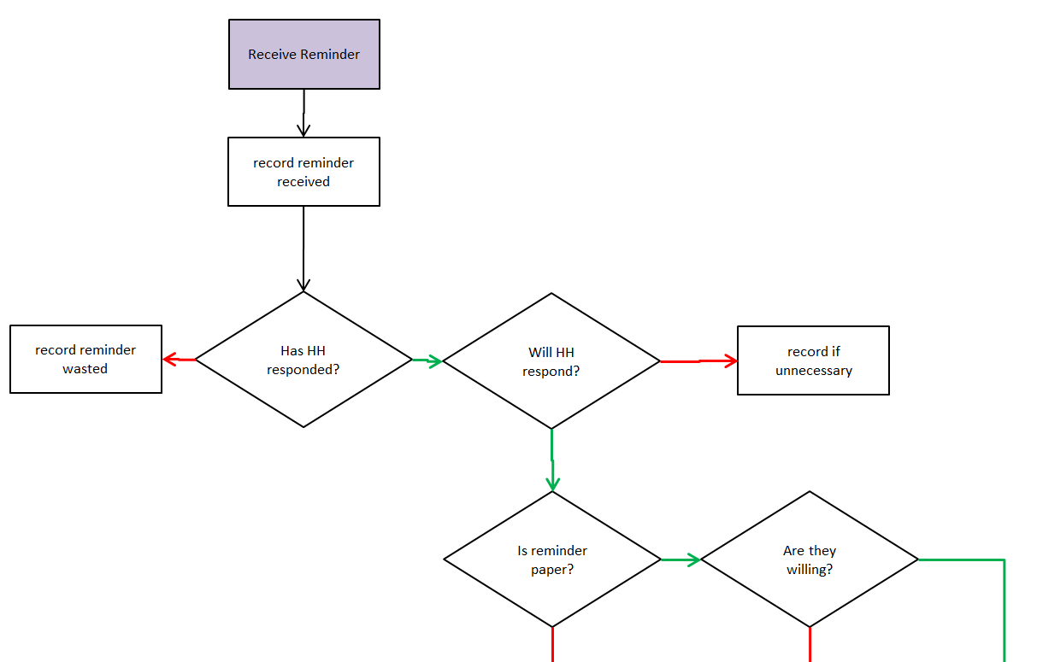

Figure 2. Part of a process model used to describe the paths the simulation can take when a household receives a reminder letter.
The FOS is implemented in Python using the SimPy module and object-oriented programming methods. It is currently located within the Data Access Platform, a secure data analysis and storage hub for the Office for National Statistics. Individual simulations take approximately 3 hours to run. Inputs and outputs are stored as collections of csv files. All raw FOS outputs are provided at Lower layer Super Output Area (LSOA) geographic level and by day.
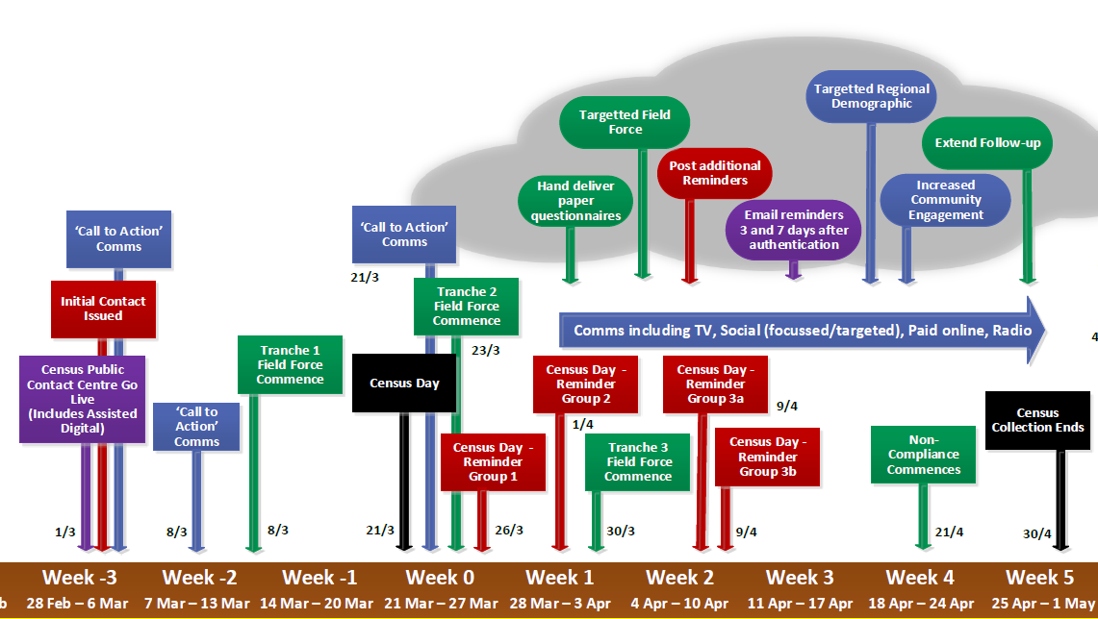
Figure 3. The Wave of Contact model.

3) Insights
FOS outputs aim to support the operational design of the Census by informing resourcing decisions. Some example insights and data outputs are summarised below.
Field staff hours by geography required to meet statistical quality targets
These are used by the Geography team to set the areas in which field officers will work, and also more widely to justify the budget required to recruit and employ them.
Expected daily return numbers by mode of response (online/paper)
These are used to predict operational loads (e.g. extra burden on the postal service caused by return of paper questionnaires, number of visitors to the Census website), for use in planning by operations teams.
Expected cumulative daily return rates by geography
These will be combined with live return data to produce insights into the progress of the live Census operation (see RCA paper [ref]).
Expected required reminder letters for each batch, by required language (English/Welsh)
With the aim of sending one planned reminder to every non-responding household, the number of required reminders therefore becomes dependent on the progress of the collection operation, while at the same time needing to be decided in advance of the operation. The FOS allows testing of reminder batches sent to various areas to develop a reminder strategy with a balanced number of reminders in each batch, helping to smooth out operational peaks.
4) Inputs and Assumptions
FOS runs on a series of statistical and operational inputs and implicit assumptions to model the expected behaviour of households and Census Officers during the Census. In order to determine the soundness of the model and its outputs, we have evaluated the quality of the inputs and the methods used to derive them. Most of the input data used in the FOS were drawn from a range of robust sources including the 2011 Census, the 2017 Census Test, the Labour Force Survey (LFS), and Driver and Vehicle Licensing Agency (DVLA) data on mode of application for driving licences. However, as will be highlighted below, some of the inputs and assumptions currently suffer from a lack of suitable data. Plans exist to address these by collecting data during the 2019 Census Rehearsal.

4.1 Statistical Inputs
The statistical inputs in FOS are generally underpinned by high-quality data which are somewhat out of date. Table 1 summarises the methodology, confidence and impact of each input. More detailed descriptions of the inputs are provided in the paragraphs that follow.
Table 1. Statistical inputs used in FOS.
Input | Methodology | Confidence in assumption | Impact of getting this wrong | Mitigation
Hard-to-Count (HtC) Index | 2011 Census day 10 response rates, updated with admin data. | High | High
Overall Willingness | 2011 Census day 10 response rates | High | High – simulation shows 5% drop in willingness leads to over £16 million operational cost to achieve statistical quality targets. | Ongoing validation against survey response data & effective media strategy.
Response profiles | 2011 Census patterns of returns adjusted for digital first strategy, updated using admin data | Medium | Low | Response Chasing Algorithm (RCA) to respond to shortfalls
Household composition & counts | 2011 age & sex of HRP data adjusted to ABP address counts + 2% | High | Low (dependent on degree of variation) | High quality address frame
Reminder Effectiveness | 2017 Census Test treatments | Medium | Medium | RCA, Interventions
Propensity to respond online/paper | 2017 Census Test treatments | Medium | Low | Increased levels of operational load to match programme assumptions.

The Hard-to-Count (HtC) Index is one of the core statistical inputs on which the FOS relies. The index contains five categories (1 – 5) that rank the typical behaviour of sub-populations/geographical (LSOA) areas in terms of their likelihood to respond to the Census, with the highest (HtC 5) signifying the greatest risk of Census non-response. The percentages of LSOAs in each category are 40%, 40%, 10%, 8%, 2% for categories 1 to 5 respectively. HtC ratings are based on data regarding households’ willingness to self-respond. The Willingness component of HtC comes from 2011 Census returns data by day 10 divided by returns from the point the Census Coverage Survey (CCS) commenced. HtC was developed by another team in Methodology and has already undergone thorough internal and external review (Dini, 2018). When used in the FOS, each HtC group is further stratified by the age and sex of the Household Reference Person (HRP) to define a list of 50 household types. This typology is used to structure other input data throughout the simulation.
Response profiles are estimates of the percentage of responses we expect to receive daily throughout the self-response part of the Census collection period (Meirinhos, 2019). These estimates are based on the response patterns of the 2011 Census, where each LSOA had a response profile that is associated with its demographic variables and Hard-to-Count (HtC) rating. Profiles for each age group were generated by extracting the response profiles of LSOA areas where this age group was a majority. Although this is not entirely accurate at representing areas with a mix of age groups, due to the methodology of applying LSOA-level data to individuals and then re-aggregating to LSOA-level, the approach was deemed good enough to highlight the main differences in timing of response between areas.
Household composition & counts define the numbers of households that exist in each LSOA, stratified by age and sex of the Household Reference Person (HRP). This information is derived from the 2011 Census post edit and imputation datasets. These numbers are then adjusted up using the counts of residential addresses from Address Base Premium (ABP) Epoch 42(E42), plus an extra 2% to account for further growth to 2021.
Reminder effectiveness and propensity to respond online/paper were both estimated using data from the 2017 Census Test. Both assumptions utilised the treatment design of the Test, which made it possible to quantify the impact of different types of reminder and operational conditions on households’ response rates.
Reminder effectiveness refers to the percentage of non-respondents sent a reminder who subsequently respond as a result of that reminder. Lessons from behavioural insights gained in 2017 show that the style of a reminder letter has a large impact on its effectiveness among different groups, and the fact that the Test and the 2019 Rehearsal are both voluntary means that it is impossible to obtain fully accurate data on how non-respondents will react to the 2021 style of reminder in a mandatory context.
The propensity to respond online refers to the proportion of people who choose to go online when provided with either 1) a paper questionnaire or 2) an Internet Access Code (IAC) as a first point of contact. The main contributing factor to this variable is age, although future work is planned to implement the Digital HtC index to increase predictive power by geography. The Digital domain of the HtC index measures preferences for accessing government services (such as driving licence applications) online.
The current propensities result in approximately 15% of overall responses occurring on paper. As the Programme is currently planning for 25% paper response, with contingency of 45% paper response, outputs used for operational load testing of paper services (e.g. paper returns by day) are provided boosted up to match these plans.
4.2 Operational Inputs
The operational inputs in FOS rely heavily on management data collected during the Labour Force Survey (LFS, years 2011 to 2017 inclusive), a comparably large-scale study of UK households. These data include records for both telephone and doorstep interviews over different days, times and geographical areas. While LFS data provide good estimates for some of the operational conditions that can be expected during the Census, we currently lack the level of detail necessary to produce reliable estimates for all inputs (e.g. travel times, visit success rates). Table 2 summarises each of the operational inputs used in FOS.
Table 2. Operational inputs used in FOS.
Input | Current Estimate | Methodology | Confidence in assumption | Impact of getting this wrong | Mitigation (statistical & operational)
Contact rates | 22%-40%, dependent on age/sex/HtC/ visit times | LFS data, 2017 Test data | High | High | Robust data regularly updated. Leave postcards if no contact is made.
Visit success rates | 30%-45%, dependent on age/sex/HtC/ visit times | No robust data available. Limited LFS data, 2017 Test data. | Medium | High | Data from 2019 useful although voluntary. Staff training, design of roles.
Time of day for visits | 60% evenings & weekends | LFS data, admin data | High | Medium | Robust data. Contract conditions, training.
Visit duration | 2-30 minutes, depending on type of visit | No robust data available. Limited LFS data, 2017 Test data. | Medium | High (extra minute for each visit has £8.3m operational impact) | Essential to get 2019 data to validate assumptions. Staff training.
Travel times | Average 8 visits per hour, assuming officers move in a straight line at 5km/h between houses | Based on density of non-responding households for a given area per day. | Medium (low in rural areas) | High (greater in rural areas) | Data from 2019. FWMT workload optimisation, patch ownership.
Paper strategy | Approx. 12% receive paper as first point of contact | Digital HtC | Complete | N/A | N/A

Contact and success rates refer to the effectiveness of Census Officer visits. Contact rate is the estimated percentage of visits that lead to any form of contact with an occupant of the household. As this is unlikely to be affected by how well-trained the interviewer is or the nature of the survey in question, we consider the source robust. Success rate is the percentage of contacts that lead to an interview or Census return within 5 days.
Time of day for visits refers to the distribution of visits throughout the day that is recommended to achieve the best contact rates, as gleaned from LFS data.
Visit duration refers to the doorstep routine of Census Officers while they are at a household. There were no suitable data sources that gave a reliable indication as to the likely length of time spent on visits. Visit time was recorded by some field staff during the 2017 Test Census, but this was not done consistently. Clerical searching of the 2017 Test records indicated times of approximately 2-3 minutes for visits where residents were out or just needed a simple nudge, and up to 30 minutes for cases where comprehensive digital assistance was provided. This limited evidence and anecdotal information from other surveys were used alongside expert guidance to produce conservative visit duration estimates that are currently used in the FOS.
Travel times refer to the time it takes Census Officers to move between households. These are currently based on an approximation where the average distance between non-responding households is calculated at the start of each day and divided by an average travel speed to give the time spent travelling between each visit. Assuming that Census Officers will travel at 5km/h in a straight line between houses, the average number of visits per hour in the simulation is 8.
Because visit duration and travel times will determine the number of household visits that can be achieved by Census Officers within a given time, these assumptions will have a significant impact on the response rates. We will be recording visit and travel times during the 2019 Census Rehearsal to produce more accurate estimates.
The paper strategy specifies the format in which the Census will be delivered to households. This is implemented in the simulation using a list of LSOAs that will receive online/paper questionnaires. This list is based largely on the Digital HtC index, with some additional areas for consideration e.g. LSOAs with a high percentage of orthodox Jewish households. The full paper strategy consists of approximately 12% of the country receiving a paper questionnaire as first contact, the ability to request a paper questionnaire by telephone, and paper questionnaires delivered as part of follow-up activities.
4.3 Implicit Assumptions
While many of the assumptions used in the FOS are explicitly determined by the input data supplied by the user, the simulation also contains a lot of implicit logic. The implicitness of some assumptions is necessary in creating an abstraction of reality that is sufficiently simple to understand and use. Implicit assumptions are hardcoded into the simulation and remain hidden during general use because they represent information that is likely to stay the same for every scenario that is simulated. Below we discuss some examples of the implicit assumptions that users and stakeholders need to be aware of.
The propensity to respond online is stratified by age, sex, and HtC, with the assumption that urban and rural areas do not differ in their digital manner other than through these variables. However, geography will have an impact on the online/paper split. Further work is planned to integrate the Digital HtC index into the model to address this problem.
The statistical design of the simulation makes some implicit assumptions. For instance, the effectiveness of visits or reminders is modelled to be the same over each iteration of interventions in the simulation. This is likely a flawed representation of reality, since the effectiveness of a given type of reminder will have diminishing returns if sent repeatedly to the same group.
There are various implicit assumptions related to operations. For example, we assume that paper questionnaires requested via phoning the Contact Centre will be delivered to households within 2 days. Such operational assumptions may need to be changed as new information becomes available or when amendments are made by partner organisations.
We are striving to ensure that implicit assumptions such as those above are not overlooked during the ongoing development and improvement activities on the model.

4.4 Best and Worst-Case Scenarios
To support resourcing decisions and contingency planning, FOS has the capacity to produce outputs for various different scenarios.
The best-case scenario assumes a 74.5% response rate at day 10. This was derived directly from 2011 Census response data. However, the Programme is currently working to a 70% self-response rate target as self-response rates to surveys are decreasing year-on-year.
A possible ‘worst-case scenario’ was devised by reducing the willingness values and visit success rates in the best-case scenario by a specified factor for each HtC group. After incorporating the above reductions into the simulation, the worst-case scenario was estimated to give a 73.35% self-response rate. Field staff hours were increased accordingly to ensure that we still met our success criteria.
It should be noted that the above estimate is not a ‘worst-case’ in the usual sense of the term, as the figure was adjusted to be workable under external strategy and operational constraints. A different pair of worst-case scenarios were estimated under 65% and 70% response rates. However, they were discarded as it would not be possible to cater to their operational implications.
The current intent is to revisit this problem once data from 2019 is available on field visit timings and effectiveness, which along with self-response are the other large drivers on the needed scale of the operation to achieve our statistical quality targets.
5) Results and Comparisons with Live Data
The FOS model has been validated using 2011 Census and 2017 Census Test data, to ensure that the values and patterns produced by the simulation match actual observations (Barber, 2018). The following subsections summarise these validation exercises. Additional validation will be carried out using 2019 Census Rehearsal data.
5.1 Validation using 2011 Census
A validation of an early version of the simulation was carried out using the 2011 Census. The aim of this was to ensure that a simple implementation of the FOS concept would behave as required and produce outputs in the form needed. This early validation exercise was not intended to confirm that the model was ready to support decision making over and above the decision to continue developing the FOS. A comparison of high level results such as response rates and staff visits required alongside the 2011 Census data showed good agreement with the behaviours observed in reality.
5.2 Validation using 2017 Census Test
The 2017 Census Test was a large-scale ‘digital first’ event that provided the first opportunity to validate the full functionality of FOS and its readiness to support decision making. The design of the 2017 Test included a number of treatments, providing sets of empirical data that made it possible to cross-validate different elements of the simulation in isolation.
Input parameters were generated using a random sample of each treatment’s data. These parameters were used to simulate predicted results in FOS which were then compared against the actual result from the remainder of the Census Test sample that was not used to generate the parameters. As shown in Figure 4, good alignment between predicted values and real data was observed. Where discrepancies exist, these can be explained by either operational issues during the Test or differences in terms of the Test being voluntary and the Census being compulsory.
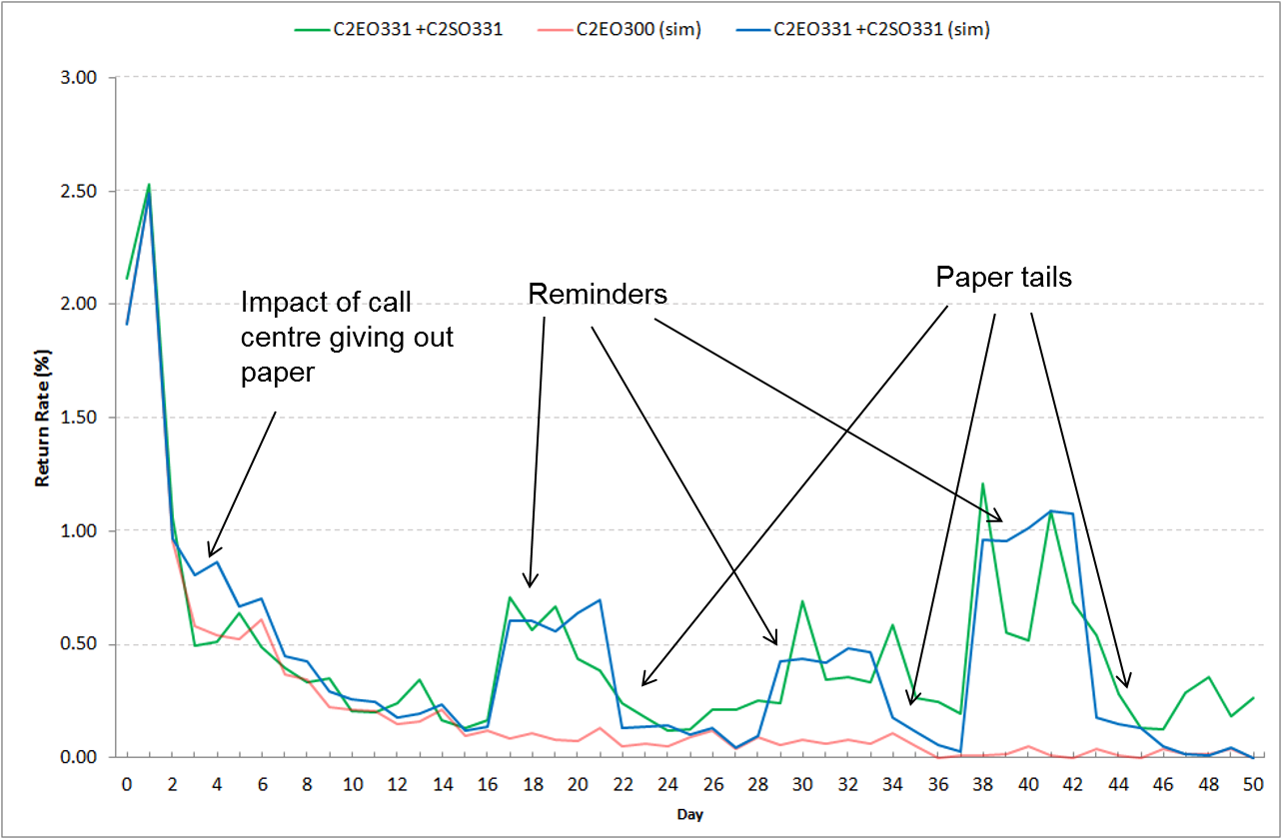
2017 Test data
baseline
simulation
Figure 4. Actual and simulated response profiles, showing the effect of reminder letters.
It should be noted that the validation exercises performed so far were not aimed at testing whether the simulation predicts the right result, but rather as a way of ensuring that when the correct inputs are used (as derived from the Test) the correct outputs are seen, confirming that the underlying processes are working as intended. Because the forecast was constructed using observations from the entire Census operations period, this method of validation may not be enough if we are looking to confirm the model’s ability to predict the future. It may be worth constructing training and validation sets that consider the time-series aspect of the data. For example, instead of using random sampling, the simulation parameters could be generated using data from the beginning of the Census collection period, and data from the remaining days could be kept aside to validate the model’s capacity to predict future outcomes.
Predictions for 2019 and 2021
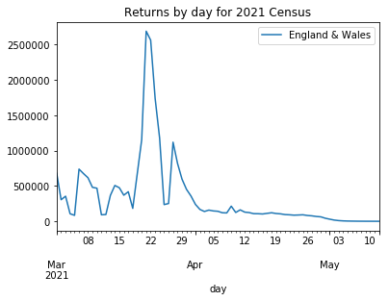
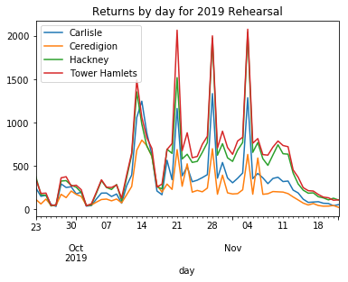
Self-response in 2019 is likely to be low (as participation is voluntary) so the graph is dominated by the effects of field follow-up, and the three planned phases of reminder letters that together target all non-respondents. In contrast, self-response in 2021 dominates the graph.
In practice, there will be large changes to the self-response curve based on a decision taken to remove Census date from the initial contact letter to lessen the load on the website on Census day. We have yet to appropriately model the effects of this.
6) Risks and Mitigation
The FOS is heavily used in supporting operational decisions during the 2021 Census. The accuracy of the model’s predictions and appropriate use of its outputs will be paramount to meeting Census quality targets.
To mitigate the possible risks and consequences of an oversight, we are striving to make the workings of FOS as transparent as possible to all stakeholders. The following subsections outline the risks and quality assurance activities currently taking place. Through highlighting areas for development to our peers and external experts, we are actively seeking opportunities to collaborate and harness input that improves the quality of the model.

6.1 Risks
The risks of the FOS (and of simulation in general) fall into three core areas:
Assumptions
The Census occurs every 10 years, and a lot has changed since 2011. The underlying data used to construct the simulation has been drawn from a range of data sources, many of which are unavoidably out of date. Although best efforts have been made to identify and correct for changing environmental contexts, the lack of an ongoing real-world operation to model means that we will not know whether many of our estimates are correct until it is too late to correct them.
Another risk relates to the way in which assumptions data are structured. The inputs are stratified by age, sex, and HtC, where possible sources of variation within these categories are disregarded. For example, geographic fluctuations would be overlooked at the small area geographic levels.
Another risk is that the simulation is built on operational assumptions that may change later. For example, the model currently assumes that respondents are provided with a Census date, during which a peak in responses is expected. A strategic decision to remove the Census date from questionnaires would likely help to even out such peaks, but the precise effect of the new approach is not currently addressed in the simulation.
Verification errors
The Census is a large and complex operation, and to model it the FOS incorporates complex decision logic and large amounts of input parameters. Care must be taken when constructing and analysing scenarios that the scenario in question is drawing from the correct set of input parameters and the code is working as it should.
While the FOS draws from random distributions, and therefore results can vary between replications, the effect this has on the outputs is minimal as the sample sizes are large. Running multiple replications and taking average values is only worthwhile when using outputs at small-area geography level.
Inappropriate usage of model outputs
Many people (especially non-analysts) tend to put too much faith in the results of a simulation, believing that because of their existence they must be both comprehensive and accurate. If model outputs are used inappropriately, this can end up actively detrimental to an operation.
An example was found in the RCA, which originally used as its prioritisation mechanism the shortfall between actual and expected returns at LSOA level. As this is highly sensitive to errors in the expected returns (derived from FOS), a forecasting method was developed to instead use both the expected and live data to predict return rate at the end of the operation, and then assess this against our statistical quality targets.
6.2 Quality Assurance (QA) activities
The value of FOS outputs is dependent on the quality of the input data, the robustness of the methodology, and the assumptions underpinning the model. As such, thorough quality assurance (QA) of the model is essential. However, the technical complexity of FOS has meant that acquiring comprehensive QA of the simulation has been a significant challenge.
The logic behind each of the steps simulated by the model was assessed at each stage of its development through consultation with peers at the Maximising Response Working Group and with experts at the Census Research Assurance Group meeting. A process is now in place to assure the model more thoroughly following government guidelines (BEIS, 2015), focusing on the areas of:
- Documentation
- Structure and Clarity
- Verification
- Validation
- Data and assumptions
We have recently secured support from the Data Science Campus to review the FOS, including quality assurance of code and help in identifying any areas where further improvements could be made.
7) Summary and Future Work
The FOS incorporates a rich selection of intelligence to simulate Census operations on a vast scale. It captures complexity to a degree that exceeds the analytic capacity of more traditional methods. FOS outputs are already contributing valuable insights to inform the operational design of the Wave of Contact strategy for the 2021 Census, and revealing cost savings for the resourcing decisions that will be made by the Census Transformation Programme.
The FOS will undergo further improvements to maximise the dependability of its outputs, using data on field visits gained during the 2019 Rehearsal. The Rehearsal will also serve as a validation test of its use for the Response-Chasing Algorithm during live operations.
Our modelling is by no means perfect. The purpose of the model is to provide insight leading to better decision-making, rather than constructing a picture of reality as an end in itself. In this sense, we are confident that the simulation is relevant and valid in fulfilling its intended purpose.
References
Barber, P. (2018). Simulating the Census using a discrete event simulation – validation (ONS internal paper available at https://share.sp.ons.statistics.gov.uk/sites/MTH/Cen/2021/Sample_Design_and_Estimation/Field_Operations_Simulation/FOS%20-%20validation%20paper.docx)
Dini, E. (2018). Hard to count index for the 2021 Census (ONS internal paper available at https://share.sp.ons.statistics.gov.uk/sites/MTH/Cen/2021/Sample_Design_and_Estimation/Hard_to_Count/HtC_index_report_v5_for_External_Assurance_Panel.docx)
Meirinhos, V. (2019). Maximising response – 2019 Rehearsal response profiles (ONS internal paper available at https://share.sp.ons.statistics.gov.uk/sites/cen/csod/CSOD_Stats_Design/Maximising_Response/Response_Profiles/Response_Profiles_2019_CRAG.docx)
BEIS (2015). Business, Energy and Industrial Strategy, Quality Assurance Tools and Guidance – Template for Non-Excel Models (Available at https://www.gov.uk/government/collections/quality-assurance-tools-and-guidance-in-decc)

94% overall response, at least 80% response in every local authority, minimised variance within local authorities and Hard-to-Count groups.
Lower layer Super Output Area (LSOA)
The willingness component of HtC is equivalent to the Willingness assumption that is used separately in FOS.
The demographic characteristics of each LSOA were updated using additional information from the Statistical Population Dataset (SPD 2016).
The operational design of the 2017 Census Test is described here. This included several ‘components’ and ‘treatments’ designed to test the effect of using different interventions and questionnaire formats.
Fieldwork Management Tool (FWMT) is an electronic tool that will be used by field staff in 2021.

