Accredited Researcher Application Guidance

Background

The following legal gateways allow accredited and approved researchers to access data for research and statistical purposes. The Digital Economy Act 2017 (DEA) (Part 5, Chapter 5) includes an important statutory framework to support the UK research community, both within government and beyond, that permits public authorities to share de-identified information with accredited researchers for the purposes of public good research. The Statistics and Registration Service Act (SRSA) 2007 at s.39(4)(i) allows access to unpublished data held by the Office of National Statistics by approved researchers for the purpose of statistical research.

Both gateways aim to broaden the capacity of research to deliver direct and indirect public benefits, including the production of valuable new research insights about UK society and the economy. All projects involving access to data for research purposes using the SRSA Approved Researcher gateway and the DEA Research power will be consistently accredited using the Research Code of Practice and Accreditation Criteria.

The Code also sets out the criteria for the accreditation of processors, research projects and researchers and the Authority has established the Research Accreditation Panel (RAP) to independently accredit each of these.

Researcher Accreditation

There are two different types of individual accreditation; Full Researcher or Provisional Researcher.

To be a Full Accredited Researcher, an individual must meet the following criteria:

1. Have an undergraduate degree (or higher) including a significant proportion of maths or statistics, or be able to demonstrate at least 3 years quantitative research experience; and
2. Have successfully completed a Safe Researcher training course run by ONS, or another equivalent course which has been recognised by ONS such as is run by the UK Data Service, the Administrative Data Research UK partners or HM Revenue and
Customs;
- Agree to their inclusion in a list of all Accredited Researchers, published on the UK Statistics Authority website;
- Agree to publish the results of all Accredited Research projects completed as an Accredited Researcher; and,
- Sign and adhere to a formal Accredited Researcher Declaration.

Researchers who do not meet the first criteria, may apply for Provisional Researcher accreditation. There is a separate application form for Provisional Researcher accreditation.

Application Process

Applications should be submitted to the via the Research Accreditation Service online portal. Once the application has been received, you will be sent a confirmation by email. The application will be reviewed by the team to ensure that all relevant fields are completed and for an initial assessment.
The Research Support team will contact you with details of how to book onto the Safe Researcher training offered by ONS or another approved training provider, e.g. UK Data Service. We advise researchers to book training as soon as possible to avoid any potential delays to the application. Ordinarily we see bookings made within two weeks of the communication for available dates.

Once you have successfully completed the training, you will need to sign an Accredited Researcher declaration, if you have not already done so with your application.

Following completion of the training course, you will need to take and pass a training assessment. Once this is successfully completed, your application will be submitted to the Research Accreditation Panel for consideration. Subject to their approval, we will confirm your accreditation and provide you with an AR number. Your details will subsequently be published on the UK Statistics Authority website, along with details of your research projects/exploratory analysis, in the public record of Accredited Researchers.

Full accreditation lasts for five years. Completing the application form All sections must be completed.

Your Details

These details will be used to contact you, and to confirm your identity when you attend an approved training scheme, (e.g. Safe Researcher training) or access data at an Accredited Processor (a list of these will be published on the UK Statistics Authority’s website), to carry out your research.

If you work for more than one organisation, please complete this section providing details of your primary employer.

Please provide your work address, telephone number and email address rather than private details. If you are applying for researcher accreditation in a private capacity, please write ‘none’ for your organisation in section 2 and we will use your personal contact details.

Individuals based overseas can apply to become Accredited Researchers, but any projects must be undertaken within a UK based secure environment and must deliver a public benefit to the UK.

If any of these details change, please let us know by contacting us at Research.Accreditation@statistics.gov.uk.

Your organisation Details

Enter details here if you are applying to be an Accredited Researcher in connection with work you do for an organisation. If you are applying for researcher accreditation in a private capacity, please just write ‘none’.

Qualifications

The qualifications required are an undergraduate degree (or higher) that included a significant proportion of mathematics or statistics. As a guide, about 50% of the degree should cover research methods components and analytical fields, including:
  - qualitative data collection and research design, including: interviewing skills, conducting focus groups and ethnographic methods
  - quantitative data collection and research design, including: questionnaire design, sampling and weighting
  - hypothesis testing and evaluation
  - undertaking systematic reviews
  - data analysis, including data linkage, imputation and presentation of results
  - application of ethics to research

As well as stating the type and subject of your qualification (such as BSc Mathematics) and the institution that awarded the qualification, you should also give details of the relevant mathematical, research and statistical techniques you learnt along with an indication of what proportion of the course was spent on them. Other relevant undergraduate degrees may include: psychology, demography, social policy, sociology, political science, geography, economics, and social statistics.

If your qualifications do not meet the requirements for accreditation, or you are unsure whether they are sufficient, please enter all of your relevant experience of carrying out quantitative data research. This will be considered in place of a formal qualification.

Even if you have completed section three and believe that your qualifications clearly meet the requirements for accreditation, it would be helpful if you would complete section four (Research Experience).

Note: to place an ‘x’ into the available check boxes, please double click on the box and select ‘checked’ under the Default Values heading in the menu that appears. To save your changes and close the menu, click ‘OK’.

Research Experience

The requirement for at least three years of quantitative research experience can be demonstrated from a single role (if three years or longer), or from a few different roles/employers. The experience can also be gathered from quantitative research undertaken during academic study.

The details of quantitative research that you provide must name the specific statistical techniques you used.

Experience Using Data for Statistical Research

As quantitative research experience is one of the possible criteria for accreditation, evidence of such experience is useful in assessing your application. You should pick one piece of statistical research that you were involved in and identify those aspects that you contributed to. If you find it difficult to identify just one piece of research you can mention another one in section 6.

Any other Information

This information could include other qualifications or experience you feel will support your application for accreditation. If you include references to published papers, please ensure that you include links to publicly available versions that are not behind paywalls.

Transparency

The UK Statistics Authority requires that relevant details of Accredited Researchers and their projects are included in a public record on the Authority’s website, and that the project results are published. The UK Statistics Authority will only grant exemptions in exceptional circumstances.

Each request for a name and/or project to be withheld from the public record will be considered by the Research Accreditation Panel. If the Panel decline the request, you will be given the option to withdraw your application.

Submitting your application
Once completed, please return an electronic copy of your completed application form to Research.Accreditation@statistics.gov.uk.

UK Statistics Authority

Accredited Researcher Application Process

Provisjonal AR

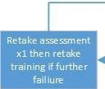
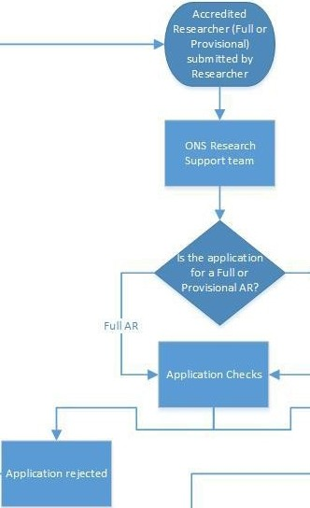
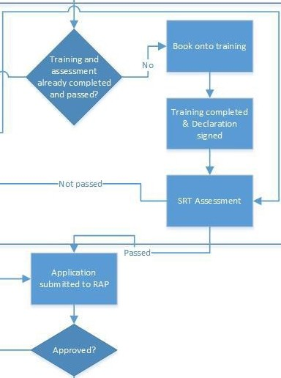
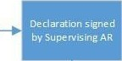

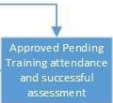

Yes

Yes

