2021 Census Editing and Imputation Strategy

1.0 Introduction and overall aims of the E&I strategy

Editing and imputation (E&I) is an important framework of methods and strategies used to adjust census and survey data to mitigate the problems arising from missing and inconsistent data (De Waal et al., 2011).

Missing data can lead to risk of error or non-response bias in census estimates, particularly if it is associated with a distinct respondent sub-population. Inconsistent responses can lead to implausible or highly improbable relationships emerging in census estimates and published outputs.

Editing processes serve first to identify and localise errors in the data and imputation is the application of methods and strategies that resolve or ‘clean’ the errors identified through the editing process.

As such, one of the traditional aims of the England and Wales Census Programme has been to produce a complete and consistent census database through editing and imputation of all census variables (Wardman, Aldrich, & Rogers, 2014). This meets user needs for complete coverage, and reduces any bias in the results arising from differences between the characteristics of respondents and non-respondents.

As of the 2010 Census round, around 70% of National Statistical Institutes (NSIs) carried out item imputation on their census data (United Nations Statistics Division, 2011). While some NSIs impute only a handful of high priority variables at the item level e.g. Australia (ABS, 2016) and New Zealand (Stats NZ, 2006), the traditional ONS approach mirrors that of, for example, South Africa (Statistics South Africa, 2011) or Canada (L. Guertin (personal communication, December 10, 2018), where all census variables are edited and imputed.

Establishing a clean and consistent census database is not a trivial task, but production of a fully populated database across all variables helps to maximise the utility of the census data, allowing ONS and external users to consistently define a wide range of population estimates and coherent cross-tabulated outputs from the national to small area level with relative ease.

As the UN Handbook on Population and Household Census Editing (United Nations Statistics Division, 2011) explains, if unedited tables are disseminated, both analysts and policymakers will have to make assumptions about the data. The publication of unknowns in output tables can also present problems when analysing trends across time. Missing values and errors can therefore make the data difficult to use and, ultimately, can be detrimental to the accuracy and reliability of census estimates, which risks damaging political and public confidence in the census and in ONS.

As such, the aim of this paper is to set out the principles of the 2021 E&I strategy given the overall aim of producing a single fully populated, consistent census database.

2.0 Why do we need statistical editing and imputation?

Imputation can be rule-based/deterministic or statistical/probabilistic. Rule based imputation tends to lead to the same outcome in every application. In contrast, because statistical imputation is probabilistic, it may yield a different outcome in subsequent applications. Except for extremely rare cases where there can be no uncertainty about the value of a missing data value or the way an inconsistency should be resolved, all missing and inconsistent values should be imputed statistically to reflect this uncertainty.

A statistical imputation strategy replaces missing values by drawing from a statistical model of the observed data with the aim of accurately estimating the distributional properties of the missing values. Inconsistencies are also resolved according to data driven probabilities. An alternative approach such as an inappropriately applied deterministic ‘if-then’ rule based adjustment will inevitably lead to the risk of introducing bias or error into census estimates.

While preliminary, rule-based, data cleaning strategies are applied to remove some of the errors found in the census data, in general, there are three types of error which should not be resolved by pre-processing:

- Missing Values: Discrete missing values occur where respondents have failed to provide a response to a particular question. They can also occur where one of the pre-processing stages has been unable to resolve a particular error in a way that leads to a valid observation.
- Within Person Inconsistencies: Within person inconsistencies occur when two or more responses for a particular individual are implausible or invalid e.g. an individual cannot be eight years old and married.
- Between Person Inconsistencies: Between person inconsistencies occur when two or more responses between two individuals in a household are implausible e.g., a mother cannot be younger than her child.

Fundamentally, these types of error are a statistical problem. Moreover, resolution is beyond the scope of a typical pre-processing data adjustment. For example, if an individual reports that they are eight years old and are married, it could be either the age or the marital status that is in error, or indeed both. Consequently, it is important to resolve these errors with an appropriate statistical E&I method.

3.0 The 2011 and 2021 Census E&I strategies: Comparability or significant change?

Historically, as there tends to be a significant degree of consistency and similarity between consecutive censuses, the development of a new census E&I strategy tends to roll forward the aims and objectives from a previous census as a useful starting point (Wardman, Aldrich, & Rogers, 2014). This serves to facilitate comparability of census estimates over time and ensures that lessons learned from a previous census are fully exploited.

However, it is worth noting here that some important differences are expected between the 2011 and 2021 Census data, and that these may suggest adjustment to the aims and objectives for the 2021 E&I strategy compared to that of 2011:

- Census responses will be primarily collected using an online collection instrument. With automated editing and no scanning error associated with Electronic Data Capture (EDC), census data tends to be cleaner and more consistent than that collected through a traditional paper questionnaire (Cote and Laroche, 2009; Ghee, 2014; Rogers, Dyer, & Foley, 2014).
- The census data may be collected in a different way than in 2011. Changes to 2011 data structures and coding frames could apply to any number of census variables in 2021.
- It is also quite likely that there will be changes to the census question set reflecting changes in the social landscape and the changing demands of users of the census data keen to understand them, such as the introduction of new questions about sexual and gender identity.
- Use of administrative data to support collection and processing of census data.

Despite these differences, we contend that the requirements of the 2021 edit and imputation strategy are still fundamentally the same as in 2011. Achieving the ONS target to collect the majority of data electronically does not eliminate the need for an accurate and efficient imputation strategy as there will still be missing and inconsistent values in the census database, and of course, the use of paper questionnaires will not be fully eliminated. Also, although it is likely that there will be some changes to coding frames and some additional questions, the 2021 Census question set requiring imputation will be broadly comparable to that of 2011. Furthermore, while administrative data may be available to support census processing, it will not remove the need to carry out traditional editing and imputation.

Additionally, as in 2011, we expect there to be a requirement to impute the Census Coverage Survey as accurately as possible to ensure that coverage adjustment is also as accurate as possible. Furthermore, it is also still likely that imputation will be required to complete the set of responses in the records added to the census database by the adjustment process.

To maintain comparability and build on lessons learned from previous censuses the E&I strategy for 2021 will therefore again be applied through similar pre-processing and a statistical imputation phases as it was in the 2011 Census but with specific attention paid to taking into account changes since 2011.

4.0 High level objectives: Pre processing & Statistical E&I Stages

To meet the requirements of the 2021 Census Programme, we propose that the pre-processing and statistical E&I stages of 2021 E&I strategy should have the following high-level objectives:

4.1 Preliminary data cleaning

Typically, in previous censuses, certain types of data error have been identified and resolved through a series of preliminary data-cleaning strategies known as ‘pre-processing’. These types of error include:

- Census forms that have been returned with only one or two questions completed, making it difficult to know whether the form is an actual response or not.
- An individual or household returning more than one response, perhaps submitting both a paper and internet questionnaire, leading to risk of inaccurate census estimates.
- Multiple-choice ‘tick-box’ questions that have more than one box ticked, making the intended response uncertain and the data difficult to manage in later statistical processes.
- Text box responses that contain unreadable text strings, also leading to uncertainty about the intended response and again making the data difficult to manage.
- Text or tick box responses that contain invalid, meaningless, or unexpected marks, characters, or symbols, also making the data difficult to manage.
- Text or tick box responses that contain answers that are beyond an expected range. For instance, a respondent may inadvertently report that they are 200 years old. This would be a clear anomaly in published census outputs.

The editing methods used to identify these errors and the methods used to resolve them are beyond the scope of this current paper but, for the purposes of this paper it is important to note that to meet the requirements of subsequent statistical processes in terms of structural integrity, the data coming out of pre-processing will be expected to have the following properties:

- A discrete household or communal establishment will only be represented once.
- There will be a unique set of responses for each individual in each household or communal establishment corresponding with all variables in the census question set and other expected derived or coded variables.
- Where a response or value has been provided for a particular census variable it should be discrete, valid, and within the range of values expected for that question.
- Where a response or value has not been provided (or removed during pre-processing) it should be given a discrete coded value to indicate that either: (a) it was expected but is missing, or (b) it was not expected due to a response given in a previous routing question which dictated that a response for this question was not required.

For the 2021 Census, we assume that the design and development of the pre-processing strategy will address the same data issues as it did in 2011.

4.2 Statistical E&I objectives

In order to meet the overall objectives of the census, the main imputation-specific objectives are as follows:
- Use modern statistical E&I methodology consistent with internationally recognised principles and standards for large scale census E&I applications (Fellegi & Holt 1976; Wagstaff & Rogers 2006; Winkler & Chen 2001; De Waal, et al., 2011). To meet this aim the E&I methodology should:
  - Replace missing data and resolve inconsistencies for all responding households and communal establishments with minimal change to the observed data.
  - Ensure adjustments to the census database are conditioned by key joint distributions in the data.
  - As far as possible, avoid introducing bias or inconsistency into the data through the imputation process.
  - Adjust the database for non-response bias where appropriate
  - Retain a consistent approach to imputation, minimising the use of alternative fallback methods

- In addition to the edit and imputation of errors in the primary respondent census database the statistical E&I methodology should be available for the Census Coverage Survey and for partial record imputation following Census Coverage Adjustment (where new records are added to the database to account for wholly missed households).

- Statistical imputation should always be considered as the first option when there is uncertainty about how an error should be resolved. Deterministic rule-based adjustments could lead to the introduction of bias into the census database, so any of these instances should be clearly documented.

- The final imputed census dataset should meet stakeholder expectation of the responses and relationships between responses in the census data. Responses and relationships outside of that expectation will be defined by a set of hard edit rules and resolved by the E&I process.

- Where specified by stakeholders, the E&I process should not propagate rare but plausible relationships between responses in a census record through the imputation process. However, where possible, it should also avoid removing observed cases of these from the Census database. Rare but plausible relationships will be defined by a set of soft (‘outlier’) edit rules.

4.3 Meeting the general aims and principles of the 2021 Census

In addition to the specific E&I objectives outlined in Section 4.1, here we outline how the design and development of E&I strategy will meet some of the specific aims and objectives of the 2021 Census (Office for National Statistics, 2015):

Maintaining historical consistency/transparency:
- Build upon the 2011 E&I strategy
- Document changes likely to have an impact on historical consistency

‘Online first’:
- Take full advantage of areas where electronic data collection can improve the speed of processing and/or quality and accuracy of the census data.

Meeting User needs:
- Define soft and hard edit rules through an edit rule strategy developed by a working group with internal and external domain/topic experts.
- Ensure that the E&I strategy is explicit at user and stakeholder events.

Towards early release of census outputs:
- Identify processing efficiencies and invest in improving processing speed without sacrificing statistical accuracy.

Towards wider ONS benefits
- Provide detailed documentation of the structured chain of processes implemented across the end-to-end E&I process.
- Ensure edit rules and imputation methods are well defined.
- Maintain documentation of issues arising through the design and development of the E&I processing platforms.

Emphasis on quality assurance
- Ensure all E&I methods and processes are approved and signed off by appropriate internal and external stakeholders and experts through relevant boards and working groups.
- Ensure a wide range of quality metrics associated with all stages of the E&I process are captured during live processing.
- Provide appropriate measures of the uncertainty associated with the E&I process in public facing post-Census documentation.

Improvements through integration of administrative data
- Explore how admin data might be used to support and enhance processing speed and imputation accuracy in 2021 (Farber, Wagner, & Resnick, 2005; Kamen, 2005; UNECE, 2006; Zadka, & Fienstien, 2012; Dial, Enriquez, Moore, & Mosina, 2014).

Supporting harmonisation:
- Ensure well defined and open channels of communication exist between all UK devolved administrations.
- Encourage regular meetings, collaboration where appropriate, and membership of relevant working groups.

4.4 Managing inconsistencies: Hard and soft edit rules

An overall edit rule strategy has been developed to meet the objective in section 4.2 to define a set of hard and soft edit rules.

4.4.2 Background
Edit rules define the admissible (or plausible) values and combinations of values of the variables in each record (De Waal et al., 2011). In the Census these can govern relationships within and between variables and within and between members of a household.
Edit rules can be categorised into hard and soft edits:
- Hard edits identify implausible or impossible relationships. If a record fails a hard edit rule it is assumed that at least one variable must be in error. These must therefore be resolved or removed from data because a record must satisfy all hard edits in order to qualify as a valid record.
- Soft edits identify improbable relationships or outliers. It is assumed that a variable may be in error, although it is not a logical necessity, so these are allowed to remain in the observed data and a decision is made as to whether they are allowed to propagate in the imputed data or whether their use as donors is completely prevented. Violation of soft edit rules can also trigger further investigation of the data so they may be used as a part of the quality assurance process.

4.4.3 High level principles

- The final imputed census dataset should meet stakeholder expectation of the responses and relationships between responses in the census data. Responses and relationships outside of that expectation will be defined by a set of edit rules and resolved by the E&I process.

- The edit rules strategy should be user driven with the key driver being outputs. The strategy should aim to minimise the filters and adjustments required during outputs production in order to produce plausible output tables, and minimise the need for creation of new variables solely for outputs.

- Hard edits - Implausible and impossible relationships to be removed from the census dataset will be defined by a set of hard edit rules where deemed necessary by stakeholders.

- Soft edits - Rare but plausible relationships (outliers) will be defined by a set of soft edit rules where deemed necessary by stakeholders. Outliers should be allowed to propagate in proportion to their observed conditional distribution in the data so that we do not impose our world view on a changing society but take action where outliers are considered unreasonable and/or we have evidence that they are being caused by error (i.e. response errors, capture and coding errors)

- Appropriate edits should be defined based on the following principles:

Edit Type | Constraint | Source for rule | Example
Hard | Legal | Law | It is illegal for someone under the age of 16 to be married
Hard | Physically/Socially impossible | Obvious errors | A person's last year worked cannot be before their date of birth
Hard/Soft | Small sub-populations | Empirical/Operational/  Domain expertise | A father is unlikely to be more than 65 years older than his child

- These principles will govern the edit rules strategy for the England and Wales Census but should aim for consistency between devolved administrations as much as possible. Harmonisation will be supported by ensuring well defined and open channels of communication exist between all UK devolved administrations, encouraging regular meetings, collaboration where appropriate, and membership of relevant working groups.

- There should be consistency between hard edit rules used for online and paper returns i.e. between those rules applied during online completion and those applied during statistical processing. Where there are differences these should be understood and justified. Where there are differences, imputation should minimise use of donors from a different response mode in order to avoid the risk of introducing bias.

- There should be consistency between filter rules and routing used for online and paper returns to ensure consistency of data availability from subpopulations between online and paper. Where there are differences these should be understood and justified. Where there are differences, imputation should minimise use of donors from a different response mode in order to avoid the risk of introducing bias.

Note that there are two key assumptions around principles 7.0 and 8.0:
a) That the different modes are equivalent in terms of what they are measuring i.e. there is no measurement error in one mode relative to the other.
b) Where hard routing or edits are applied online (e.g. under 16 year olds are automatically routed past all labour market questions), there must be confidence that the routing variable is correct otherwise this routing risks the introduction of bias compared with paper, where it is possible for a respondent to see and complete the whole questionnaire. This can be achieved by, for example, playback and confirmation of age by the respondent after completion of the date of birth field.
- A set of rules will be developed to cover the main census database, the Census Coverage Survey database and the records added by the coverage adjustment process (subject to coverage adjustment methodology), and potentially for the Statistical Disclosure Control process (subject to methodology).

- The strategy should maintain historical consistency and transparency. It should build upon the 2011 E&I strategy and differences should be documented.

- Edit rules to govern the relationships between the census variables and any variables appended from linked alternative data sources should be developed based on sound evidence to ensure consistency, accuracy and usability of the final database. Where there is conflict between admin data and the census, the census values should be favoured due to the inherent uncertainty in any linkage mechanism and fact that the census has been specifically designed to capture the statistical concepts being analysed.

- Metrics on edit rule failures (types and distributions of failures) should be created for QA purposes and to inform onward processing and stakeholders.

5.0 Building on 2011 and lessons learnt

Since 2011, a program of work has been undertaken to support the overall objectives presented in section 4 and to address lessons learnt from 2011. Section 5 presents summaries of key pieces of research completed so far.

5.1 Selection of an appropriate statistical imputation method

In general, donor-based imputation methods tend to be preferred by NSIs around the world, including the ONS, over other imputation methods for replacing missing and inconsistent data values in a census (United Nations Statistics Division, 2011). In this approach, also known as a conditional hot-deck, adjustments to the database are made using an observed value, or values, from another statistically similar record from the same dataset. Conditional hot-deck methods are advantageous because:

- Imputed data are always drawn from the real and observed data. This means that ‘new’ values are never introduced into the data by the imputation process as they can be with other methods.
- They are non-parametric, so they avoid making too many statistical assumptions about the data, unlike parametric model-based methods.
- They are particularly useful if the distributions of the data will be analysed by users, as is the case with the census, because they preserve the shape of observed distributions.
- If parameterised appropriately they can reduce non-response bias, improving the accuracy of census estimates. Non-response bias can occur in census estimates when people with particular characteristics are more likely not to respond to a particular question or questions than others.
(Durrant, 2005; Andridge & Little, 2010).

They can also be easily adapted to apply multivariate imputation of categorial and continuous data simultaneously and therefore reproduce correlations between variables much better than single-variable imputation methods (de Waal et al., 2011). This is a key benefit in the census context due to need to produce cross-tabulated outputs.

A conditional hot-deck was used for the 1991 and 2001 UK Censuses and, prior to the 2011 Census, ONS had always invested in designing the edit and imputation processing platform ‘in-house’, such as EDIS in 2001. In general, edit and imputation of a census is an extremely difficult challenge, statistically and volumetrically. With that in mind, EDIS worked relatively well. However, it did not meet all of the aims and objectives of the imputation strategy as well as originally intended (Wardman & Aldrich, & Rogers, 2012; Aldrich, Wardman, & Rogers, 2012, Wardman, Aldrich, & Rogers, 2014). By 2006, the processing platform and complex code that ran EDIS was also already five years old and had not been used or maintained since 2001. This meant that resurrecting it for 2011 would have been difficult, if not impossible, without considerable investment in resources. Consequently, rather than invest automatically in the redesign of EDIS for the 2011 Census, all UK Census offices (ONS, NISRA, NRS) agreed to explore the statistical community and literature for an alternative ‘off the shelf’ solution.de

Through that review, the Canadian Census Edit and Imputation System (CANCEIS), which implements a nearest-neighbour hot deck approach, was identified as a promising option. CANCEIS is a licensed but freely available processing platform designed specifically for large scale edit and imputation applications such as a census, and had been used in all Canadian censuses since 1996. The ‘New Imputation Methodology’ (NIM) developed by Mike Bankier for CANCEIS at Statistics Canada specifically for census data, offers an extension and improvement on traditional applications of this method (Bankier, 1991; 2000; Bankier, Lachance, & Poirier,1999; Bankier, Poirier, & Lachance, 2001; Winkler & Chen 2001; Canceis, 2009).

Through workshops with representatives of Statistics Canada, a detailed research programme in ONS Methodology reviewed by all UK Census offices (Wagstaff & Rogers, 2006), and an external review by Southampton University, it was agreed that CANCEIS could meet the aims and objectives of the 2011 Census imputation strategy better than EDIS did in 2001.

The decision to use CANCEIS rather than redevelop EDIS had a clear advantage in that resources that might have been allocated to development of another in-house solution could instead be used to take advantage of the raft of statistical functionality already built into the CANCEIS platform. Significantly, that functionality and the underlying imputation methodology extended beyond anything designed and implemented by ONS in 2001 or for any other of the previous UK censuses.

The NIM methodology and processing strategies implemented on the CANCEIS platform are a natural extension of the Fellegi-Holt (1976) principles that underpin the aims and objectives of the 2001 and 2011 imputation strategies, and those being proposed of 2021. However, the underlying NIM method in CANCEIS meets those aims more accurately and efficiently than any other census imputation system used in the past and, as such, the software is cited as an example of a multiple-variable editing system with advantages over traditional top-down approaches in the UN Handbook on Population and Housing Census Editing (United Nations Statistics Division, 2011).

To achieve this, CANCEIS employs two well developed processing programs. The first is designed to manage the complex set of edit rules associated with the census. The second implements the imputation methodology. There are several specific advantages built into these two programs compared to previous Census E&I systems:

- In managing the census edit rules, CANCEIS has a unique computational processing strategy that can simplify the complex set of census edit rules prior to imputing the data, removing redundancy to significantly improve processing speed, and identifying where several independent edits may combine implicitly to make imputation impossible.
- In implementing the imputation methodology, CANCEIS has a wide range of user definable parameters than can be adjusted to tune the baseline methodology to meet very specific analytical aims and priorities, or adjust the methodology to suit what can be very different data from different UK regions. For instance, in 2011, a very different set of parameters were needed to impute data from Central London compared to data from rural Cornwall.
- Within a given set of parameters, the primary advantage CANCEIS has over other systems is that it automatically finds the optimal solution to a multivariate imputation task in terms of identifying the minimum number of data values required to replace missing data or resolve an inconsistency. Simultaneously, it also ensures that imputed records satisfy all census edit constraints specified by the edit strategy.
- Winkler and Chen (2001) also point out that the heuristic programming strategy and donor search algorithms through which the methodology is implemented in CANCEIS are remarkably fast and efficient.

All in all, these advantages are particularly applicable to a census because imputation involves processing an extremely large amount of data constrained by a complex set of edit rules, meaning that both statistical accuracy and processing efficiency are paramount. Flexibility is also extremely important since a fixed set of imputation parameters is unlikely to be appropriate for all the different areas of the UK.

Table 1 shows how much better CANCEIS performed across several key indicators associated with the aims and objectives of the edit and imputation strategy in 2011 compared to EDIS in 2001.

Table 1: Key indicators comparing the 2001 and 2011 imputation strategies
 | EDIS: 2001ª | CANCEIS: 2011^{b}
Person records processed | 49.4 million | 53.5 million
Average number of records in a processing unit | 500,000 | 530,000
Average time to impute a processing unit | 48 hours | 12 hours
Persons needing at least one question imputed | 13.8 million (28%) | 18.6 million (35%)
Percent imputed as a multivariate joint distribution* | 34% | 82%
Percent imputed as individuals* | 72% | 18%
Percent imputed using alternative methods | 3% | 0.10%
Persons imputed by more than one method | Over 1 million | Under 300
a. Census 2001 Review and Evaluation (ONS, 2003)
b. Data derived through the Census 2011 CANCEIS system diagnostics
* Note: These measures are not mutually exclusive so they may or may not add to 100%

In principle, CANCEIS had relatively more ‘work’ to do in 2011 than EDIS in 2001. In general, around thirty thousand more records were imputed in a 2011 processing unit compared to 2001. There was also an increase of around 7% in the number households that needed at least one value imputed. However, CANCEIS was far more efficient, completing the task on average in about a quarter of the processing time.

Perhaps more significantly, CANCEIS also met the key statistical aims and objectives of the imputation strategy far better than EDIS. There was a 48% increase in missing or inconsistent values being imputed based on observed joint distributions in the data. This would have led to a significant improvement in the accuracy of multivariate estimates and outputs based on joint distributions in the census data, particularly at low levels of geography and aggregation. This improvement was extended further by a 52% reduction in the number of people imputed as individuals without taking observed data from other members of the household into account. There was also a significant improvement in methodological consistency with far fewer people being imputed using alternative methods or different adjustment strategies to that of the baseline imputation methodology.

All in all, the evaluation of the 2011 Census E&I process concluded that it successfully met its objectives (ONS, 2012). In summary:

- The 2011 method produced a higher rate of joint imputation in a much shorter space of time than achieved in previous censuses. This meant that the hierarchical (between-person) distributions were better accounted for than in previous methods.
- After edit and imputation, the database of responding persons was complete and consistent.
- Changes to observed data were minimised by imputing inconsistencies and non-response simultaneously with CANCEIS, which minimised the changes made to failed records by selecting from a list of nearest minimum-change donors.
- The distributions of non-response were estimated for all questions, with the majority having no issues.
- Non-response bias was evident in some of the questions where the imputed values followed a different distribution to that observed. This resulted in appropriate minor adjustments to the final distributions. The most notable of these was for economic activity last week, where the final distributions were adjusted by 1.9%. These changes maintained the quality of the data.
- Application of deterministic relationship algorithms prior to statistical imputation was very effective in addressing the response errors in the household relationship matrix question and improving the ratio of donors to failed records.

The report did also identify some areas for improvement however which will need to be addressed if we are to apply the same overall approach again in 2021:

- There were some post-imputation edits required for type of second address and term-time address indicator in order to correct for cases where an appropriate donor was not found during imputation. It is thought that application of an appropriate hard edit rule to maintain the relationship between these variables during imputation will mitigate this in 2021.
- For age, there was some movement in the distributions of single years of age around the working and student age boundaries. This was identified as an area for future research (see section 5.3). However, with a maximum 0.3% difference in the proportional distribution for any single year of age, the accuracy was still considered sufficient.
- The proliferation of rare characteristics (soft edit conditions) was higher than expected. This could be mitigated in 2021 by application of appropriate hard edit rules or donor exclusion rules to prevent propagation of these characteristics (addressed in section 4.4).
- Additional deterministic edits were applied prior to imputation. Although imputing non-response and editing inconsistencies worked well for the majority of questions, deterministic editing is likely to be required to address any systematic response errors in the data. Some of these may be anticipated based on past census data, but new errors are also likely to arise. Flexibility for adding new deterministic edits prior to imputation would therefore be an advantage (will need to be addressed in further work, section 7.3)
- Processing was generally smooth and efficient, however there were some challenges in implementing the process in an automated production environment:
  - The implementation of the method was more iterative than originally planned. Future statistical projects such as this would benefit from an iterative design and testing approach with strong feedback loops and flexibility to make changes to the methods during live operations.
  - The period for tuning and parameterisation was also longer than expected. This is an important phase in the implementation and should be adequately timetabled.
  - Edit and imputation is the first step that validates consistency between different questions. It would therefore be beneficial to allow time for analysis and modification to the underlying database when edit and imputation is first run on the live data.
(all to be addressed in further work specified in section 7.3)

While the evaluation highlighted some specific areas to address, the E&I process was found to be fit for purpose. Therefore, building on the report and, in line with the objective to use modern statistical E&I methodology consistent with internationally recognised principles and standards for large scale census E&I applications, the following section sets out the rationale for implementing the same nearest neighbour hot deck imputation method in 2021 as was used in 2011.

5.1.2 Options for 2021

In principle, there are two fundamental options for the design and development of the edit and imputation processing platform for the 2021 Census: (1) we could choose to develop an alternative solution to CANCEIS, or (2) we could use CANCEIS again.

Option 1: Develop an alternative solution to CANCEIS

Here, it is important to note first that we have not been able to identify another third-party tool that will implement the NIM edit and imputation methodology used in the 2011 Census. This is perhaps not surprising since Statistics Canada license CANCEIS for free in return for feedback and collaboration that guides ongoing design and development. Consequently, CANCEIS is recognised by other NSIs and has been used by some in their own censuses (e.g., UK, Canada, New Zealand, and Australia). CANCEIS has also been endorsed by the UNECE (UNECE, 2016) as a significant contribution to the modernisation of national statistics. All in all, there seems very little point in trying to replicate it. Theoretically, it would be possible for the ONS to invest in developing a code-based platform to do this in-house. However, CANCEIS has been in development for many years with a fully funded and dedicated team of statisticians and programmers. Attempting to replicate the performance and functionality of CANCEIS is likely to demand a considerable amount of money and resources with no guarantee of success in the time available prior to the 2019 rehearsal and 2021 Census.

Alternatively, the ONS could, in principle, implement an in-house edit and imputation system with a much smaller outlay in resources than needed to completely replicate CANCEIS. However, to do this it seems extremely likely that we would have to lower our expectations of the methodology and opt for less functionality than we had in 2011. As an example, a project carried out by the E&I team to replicate some of the functionality of CANCEIS in SAS, tailored specifically to social surveys, has achieved a working (although not final) solution in the time span of a year, but the functionality of this system is very limited compared with CANCEIS, with no way of resolving inconsistencies and little of the functionality necessary for large datasets.

Pursuing this option for the Census is likely to lead to similar disadvantages in performance as those we can see quite evidently when comparing the performances of the 2001 and 2011 systems. For example, more people will probably have to be imputed as individuals without reference to joint distributions in the data within and between persons in a household. There is also likely to be a greater need for alternative, sometimes manual, fallback imputation methods.

Overall, by adopting either of these two alternatives we are at risk of investing resources in developing a system for 2021 which will be, or is very likely to be, less accurate than that implemented in 2011, rather than using a freely available platform that maintains consistency with, and builds on, that used in the previous census. Taking this risk or making this choice makes very little sense and actively works against the design principles to seek to achieve as good or better quality results than in the 2011 Census.

Option 2: Use CANCEIS again in 2021

As the design and development principles behind CANCEIS and the aims and objectives of the 2021 edit and imputation strategy are drawn from the same statistical framework, and considering that we already have a considerable amount of experience implementing it, it seems more than reasonable to suggest that we should use CANCEIS again in 2021. There are a couple of points worth making here in support of that view:

- Research related to understanding the impact of new initiatives such as EDC and the use of administrative data in imputation has indicated that we can address both directives on the CANCEIS platform in a way that could improve the statistical accuracy of the 2021 imputation strategy compared to 2011 (Rogers, Dyer, & Foley, 2014; Leather, Sharp, & Rogers, 2016a).
- Research starting to explore the log of ’lessons learnt’ reflecting issues and questions related to various aspects of implementation in 2011 has also indicated that there are various ways that we can improve on the statistical performance of CANCEIS in 2021 if we use it again in 2021 (Leather, Sharp, & Rogers, 2016c).

In general, the points we have outlined above are consistent with our working assumption that the 2021 imputation strategy should be comparable to, and build upon, that implemented in 2011.

5.13 Recommendation for 2021

We conclude that choosing to use CANCEIS again in 2021 and building on the experience from 2011 is a far better option than attempting to design and develop an alternative, in-house, from first principles.

5.2 Optimisation of donor search specification and processing unit size

Given the recommendation to apply the NIM method in CANCEIS again in 2021, a key set of decisions around application of the methodology need to be made.
The first of these centres around how to conduct the donor search. In 2011, in order to maximise processing efficiency of CANCEIS, a strategy was developed to constrain the search for suitable donors during imputation.
Firstly, rather than allowing CANCEIS to search through the whole of England and Wales for a suitable donor for a particular failed record, which would have been both resource and time intensive (and, in fact, beyond the processing capabilities of CANCEIS), the data in 2011 were broken down into 101 geographical processing units containing around 241,000 household and 530,000 person records each, which were each processed separately.
Secondly, in theory, to guarantee that the absolute best donors and imputation actions are found for each failed record, the E&I process needs to conduct an exhaustive donor search and consider all potential donors in the processing unit. In practice however this can be both time and resource intensive, especially with large datasets. Consequently, CANCEIS is equipped with the ability to perform a multi-stage search.
In the 2011 Census, upon identifying a failed record, CANCEIS searched the processing unit in several stages starting with the records adjacent to the failed record in the dataset and working outwards. At the end of the second stage of searching and every subsequent stage thereafter, CANCEIS was conditioned to make a decision as to whether or not to continue searching for donors in additional stages. If an imputation action had been found in the latest stage that was significantly better than the imputation actions found in all the previous stages, then it was assumed that it was reasonable to expect further improvements from running the next stage. If this condition was not met, or if CANCEIS had found a perfect donor match in the latest stage, it stopped the donor search for that failed record. This heuristic approach meant that CANCEIS did not have to conduct an exhaustive search for each record, saving considerable time in processing.
However, when conducting a staged search, it is important to note that if the parameterisation is too restrictive then CANCEIS could end up having to settle for an inferior donor with sub-optimal imputation actions because it could not search far enough to find the most suitable donors.
As such, an evaluation was carried out to determine whether improvements can be made to the 2011 donor search and processing unit strategy implemented within CANCEIS in order to achieve results of even better quality in the next 2021 Census. To do this, the work looked at three main factors for household persons 1-6 (who make up the vast majority of the usually resident population):
- The processing unit size
- The equilibrium between statistical accuracy and processing efficiency
- The variance of the imputation actions
The outputs of four 2011 Census processing units (approx. 500,000 records each) of varying enumeration difficulty were used to assess these factors and drew the following conclusions:
- The 2011 processing unit size and donor search parameterisation produced sufficient donor pools for CANCEIS to successfully find donors and imputation actions for the failed records, meaning that unimputed records were minimised.
- The donor search parameterisation appears to have achieved a reasonable equilibrium between statistical accuracy (defined as minimising the statistical distance between the donor and failed record) and processing efficiency, producing results that are very close to the ‘optimal’ parameterisation (defined as conducting an exhaustive search of the processing unit and limiting the final donor choice to just the best possible donor rather than picking from a range of donors), but with much faster processing times.
- CANCEIS was generally able to consistently find good quality imputation actions (minimising statistical distance to the failed record and the number of changes made to observed data) for every failed record and thus minimise imputation variance.
- Furthermore, further work has found that increasing processing size (to regional level for example) also offered no improvements in processing time, so the current processing unit strategy appears to be the best balance between statistical accuracy and processing efficiency.
It is however recognised that the donor pool sizes for five and six person households were relatively impoverished compared to the other household sizes (which is understandable given the relative paucity of larger households in the country as a whole). Whilst this did not prevent CANCEIS from finding suitable imputation actions, additional work on processing unit size could focus on evaluating the feasibility of increasing the processing unit size for five and six person households in order to reduce the frequency of CANCEIS exhausting the potential donor pool.
Subsequently, this leaves us with two options to consider:
- Given that the 2011 strategy was found to produce near optimal results for household persons one to six, it would be acceptable to conclude our work here and apply the same processing unit size and overall search parameterisation strategy as the default approach for 2021.
- Alternatively, given there could be room for statistical improvements in five and six person households due to the smaller donor pools, we could start a further phase of research looking at developing a specific processing unit strategy for these large households.

5.2.2 Recommendation for 2021
We recommend that we proceed with option 1 as this appears to provide a good balance between statistical quality and processing efficiency. This decision is supported by the fact that while there may have been fewer donors for larger households compared with smaller ones, there is no evidence that this actually had a detrimental effect on overall statistical quality. Consequently, although there may be room for some marginal statistical improvements for five and six person households, it appears to be sensible for us to move our focus to other higher priority areas in the limited time available before 2021 (see section 7.0 for outstanding further work).

5.2 Modularisation of imputation

Another key decision when designing a donor imputation strategy is whether to use a univariate or multivariate method. That is, whether to impute the target variables separately one by one, or to impute them simultaneously using the same donor for all variables.
Traditionally, it is usually considered desirable to use a multivariate imputation method for census data. This is because resolving invalid values in a record simultaneously, using the estimated multivariate distribution from a single donor, preserves the relationship between target variables (de Waal et al., 2011). It also enables the implementation of complex edit constraints which can account for the implicit and explicit routing on the questionnaire, as well as ensuring that the imputed values satisfy all of the edit rules.
It is however not always statistically optimal, or even possible, to impute all variables in a complex dataset simultaneously, especially given that, in order to maintain between person consistencies, it is necessary to apply joint household imputation. Consequently, the presence of a single missing value in any one of the fields for just one member of a household can prevent the whole household from being used as a donor, therefore reducing the size of the donor pool and consequently the quality of imputation actions.
It may also be too computationally costly to apply all edit rules and to determine the optimum imputation actions for all variables at the same time. Additionally, there may be a need to use routing variables or variables derived from previously imputed variables during imputation of other variables (Bankier, 2000).
One solution in these situations is to modularise the data. That is, to separate the imputable variables into subsets (modules) and impute just the variables in each module simultaneously, thus still enabling a level of multivariate imputation but reducing the complexity of the task. Modularisation also makes it possible to include only variables that help to predict each other in each module, therefore potentially ensuring better preservation of higher order distributions compared with a fully multivariate method. In fact, testing prior to the 2011 Census confirmed that modularised imputation produced better recovery of distributions than full multivariate imputation (internal working group paper UKCEAIWG (08)18). Furthermore, when full edit constraints were applied, the computational burden on CANCEIS was so high that it was simply not possible to successfully run the process for all variables simultaneously (internal working group paper UKCEAIWG (09)12).

For these reasons, a modularised strategy was developed for the 2011 Census and sequential multivariate imputation of the modules was carried out using CANCEIS, with the variables in each module imputed and fixed before the next module of variables was imputed. Priority was given to the key variables that defined the population estimates and bases. These were treated in the first module with variables that helped to predict them.

Table 2 sets out the modules used during the main item imputation stage 2011.

Table 2. Item level imputation groups and modules in the 2011 Census (main item imputation stage)

Data group | Module | Number of variables imputed
Observed Households | Household Variables | 10
Dummy Households | Household Variables | 4
 | Dummy Variable (reason) | 1
Residential Persons 1 to 6 | Demographic Variables | 19
 | Culture Variables | 21
 | Health Variables | 3
 | Labour Market Variables | 15
Residential Persons 7 to 30 | Demographics Variables | 15
 | Culture Variables | 21
 | Health Variables | 3
 | Labour Market Variables | 15
Communal Persons | Demographics Variables | 14
 | Culture Variables | 21
 | Health Variables | 3
 | Labour Market Variables | 15

Bankier (2000) has however identified a number of potential drawbacks of pursuing a modularised approach to imputation with CANCEIS:
- Imputation actions carried out in one module may result in observed variables in later modules being changed on the basis of these (and occasionally this may be many variables being changed on the basis of a single imputed variable). This issue is of particular importance since it potentially violates the E&I objective to minimise changes to observed data.
- A different donor is usually used for each module for a record that has multiple invalid values in different modules, which could result in the imputed record at the end of this process having combinations of responses that are implausible.
- The presence of one or more variables in a module that are unimputable because they were finalised in an earlier module may make it impossible for some potential donors to generate imputation actions which pass the edit rules of a later module. This could restrict the potential donor pool and lower the overall quality of imputation actions, risking preservation of distributions.
As with 2011, it was found that it would not be computationally feasible to impute all variables simultaneously, even with the latest version of CANCEIS, so we will need to modularise the data again. Before deciding to apply the same modularised approach to imputation in 2021 as set out in table 1, the potential negative impacts of modularisation on the 2011 Census data were therefore assessed by analysing two study areas (one containing a mix of urban, suburban and rural areas, and one urban inner London area).

5.2.1 Fixed variables leading to observed variables in later modules being changed
Investigation found that few records were affected by this in 2011 (less than 1% overall in the two study areas), with the majority being students. Ultimately, most instances could be localised to the imputation of two important routing variables in the demographics module: age and term-time address, which subsequently required all their dependent variables in later modules to be changed. Importantly, it should be noted that not all of these changes were in error. Nevertheless, in order to mitigate the few times where these changes are in error, we must ensure that the major routing variables in the demographics module are imputed as accurately as possible and with reference to their dependent variables to ensure that all relevant information is taken into account when resolving inconsistencies. This can be done by, for example, identifying additional edit rules, using auxiliary matching variables and/or making use of other data sources to support imputation.

5.2.2 Different donors used in each module leading to implausible combinations:
The investigation also showed that, in almost all cases, different donors was used when a single record was imputed in more than one module. Of the 98,000 records in the two study areas which required imputation in more than one module, almost all of them (95,000, or 97%) used more than one donor. Importantly, however, this did not appear to increase the number of rare or implausible combinations in the data since 99% of all fully observed census responses in the study areas were found to be unique across all variables anyway. Furthermore, examination of cross-module multivariate relationships found no unusual changes after imputation with the largest distributional changes occurring for common combinations such as white people under 20 years old (0.65 percentage point change after imputation), which generally appeared to reflect non-response bias.
Finally, examination of cross-module soft edit failures after imputation showed little change, again supporting the view that modularisation did not lead to an increase in implausible combinations.
While the modularisation strategy therefore definitely resulted in a substantial proportion of failed records having different donors in different modules, there is little evidence that this issue actually resulted in any significant increases to implausible combinations or had an observable effect on census estimates. Essentially, the risk of using multiple donors for a single failed record is high, but the actual impact of this appears to be low due to the high level of uniqueness in census records at the individual level.
Furthermore, modularisation appears to have had an unintended benefit in that, given the high level of uniqueness in the observed data, the use of different donors in different modules for the same recipient record will ensure that the imputation process is less likely to create imputed records that are exact duplicates of observed ones. This is particularly useful during the imputation of ‘skeleton’ records added by the coverage adjustment process which only have their key variables populated and therefore take a large proportion of their values from donor records.
As such, no mitigating action is recommended, although it does appear to be advisable to monitor cross-module multivariate distributions and soft edit failures in 2021 as part of the QA process.

5.2.3 Fixed variables preventing potential donors from being able to generate valid imputation actions in later modules
While it is undoubtedly true that modularisation would lead to the exclusion of some potential donors, it has already been previously established that a modularised strategy in the census is able to generate more appropriate imputation actions which preserve higher order distributions than a fully multivariate non-modularised approach. This is consistent with the fact that modularisation allows selection of more appropriate matching variables for different groups of target variables, and indicates that the risks of excluding some specific imputation actions are outweighed by the other statistical benefits of modularisation.
There do however seem to be a small number of specific cases in 2011 where age and economic activity last week (both in the demographics module) were inconsistent and, due to its lower weight, activity last week was changed to resolve this even though it was clear that age was incorrectly observed (e.g. respondents writing the date they completed the census form in the Date of Birth field). This could occasionally leave a record with very peculiar characteristics and make it difficult to find donors in later modules. This was frequently observed in the small number of records that failed to impute in the production system. Overall, however, there were only a handful of records in each processing unit that failed to impute and the identification of these was considered a positive at the time of the census since these records had specific errors which benefited from clerical resolution.
It is therefore recommended that no action is required to address this issue since there is no evidence that it had, or is likely to have, a negative effect during the census that would outweigh the benefits of modularisation. The number of records that fail to impute and the reasons should be monitored during the tuning stage to ensure that there are no unacceptable increases in numbers however. There should also be a clear fallback strategy for records that fail to impute so that they are resolved in a standardised manner.

5.2.4 Recommendations for 2021
Based on the research, it is therefore recommended that the modularisation strategy for the 2021 E&I process should:
- Use the 2011 strategy as a starting point but specifically address the lessons learned relating to the imputation of age and term-time address indicator by ensuring they are imputed as accurately as possible, since errors in imputation of these can potentially have knock on effects for later modules
- Ensure that key joint distributions, soft edit conditions and records that fail to impute are monitored to identify any implausible combinations that may feed through to outputs as part of the QA process
In addition, it should be noted that modularisation could confer some additional benefits in that the variables included in earlier modules (demographics and culture) which are required by the estimation process could be sent through before imputation on later modules is completed. It should be noted however that this may reduce the resolution options available if there are problems with imputation in later modules (e.g. it would not be possible to manually change the variables that had already been sent through to estimation) and will complicate both QA and process control, which may increase the risk of errors in the data being missed and increase the risk of failure of processing. The costs and benefits of this split module processing approach would need to be assessed further as part of the further work on the overall E&I process flow (section 7.3). Furthermore, running more processing units in parallel may be able to offer similar benefits to processing times without the need to segment the process.

5.3 Resolving the issue of imputation of age around the school age/working age boundary

As identified in the 2011 evaluation report, the item level imputation process for the 2011 Census resulted in a net increase of 14,061 15-year-olds and a net decrease of 13,858 16-year-olds (excluding imputation of non-response). An attempt was made to prevent this spike during live running by increasing the weight of the age variable to discourage changes to it, but this was not able to fully mitigate the issue, and an observable spike remained in the final imputation estimates (Figure 1). The difference reported at the time was initially assessed as acceptable because diagnostics focused on five year age bands and most of the movement occurred within one age band, but subsequent analysis revealed that the single year of age changes were more severe.
Figure 1. Difference in the proportional distributions of single year of age before and after imputation in the 2011 Census

Research post-census concluded that two factors contributed to this issue:
- The CANCEIS parameterisation used during the census did not sufficiently discourage 16 year old failed records from being matched to 15 year old potential donors despite these records being on different sides of the school age/working age boundary. Setting up the distance functions to more strongly discourage records on different sides of the boundary from matching was able to totally remove the spike in a test dataset with simulated non-response (Figures 2 and 3).
Figure 2. Difference in the proportional distributions of single year of age before and after imputation for the test data using the 2011 CANCEIS parameterisation
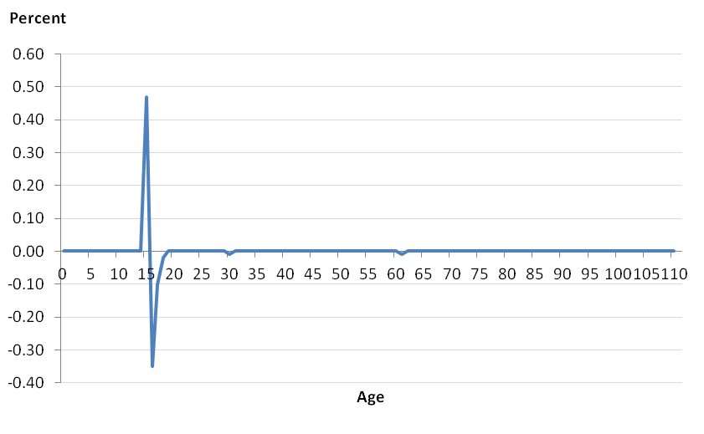
Figure 3. Difference in the proportional distributions of single year of age before and after imputation for the test data with the new parameterisation
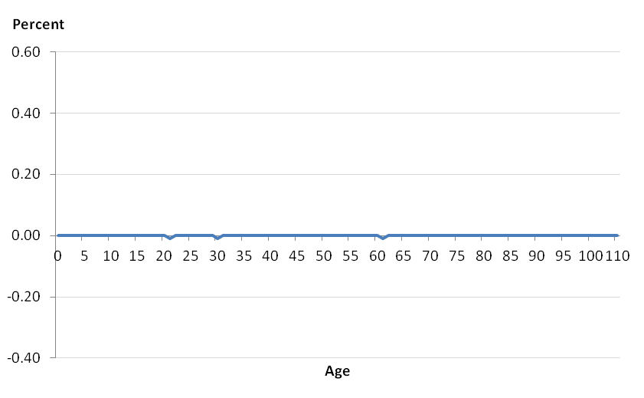

- Missingness of activity last week was particularly high for 16 year olds even though the vast majority of 16 year olds are full-time students. When activity last week was missing there were no systematic differences between 16 and 15 year olds in the demographics module, meaning that there was little to stop 15 year olds being used as donors for activity last week despite the fact that this would subsequently require an age change to 15 to maintain consistency. Activity last week is a derived variable and the answer to the ‘Are you a schoolchild or student in full-time education?’ question was not fully taken into account during derivation in 2011, so it was concluded that missingness for this variable could be reduced for young people if more information from the completed questionnaire was taken into account.

5.3.1 Recommendations
- Ensure optimal parameterisation of CANCEIS to discourage changes across key age boundaries
- Perform quality assurance checks at the appropriate level from the outset (e.g. if outputs are produced by single year of age, diagnostic checks should also be at this level)
- Revisit the derivation of activity last week to ensure that missingness is minimised and that the full extent of relevant information available from the census questionnaire is taken into account.

5.4 Imputation of the Relationship Matrix

The Relationship Matrix was first used in the 2001 Census and was developed in response to guidelines from the United Nations Economic Commission for Europe (UNECE) and the Statistical Office of the European Communities. The guidelines recommended that analysts should be able to identify ‘hidden’ and ‘reconstituted’ families resident in the population from the census data to improve the development of appropriate social and fiscal policy. To meet this recommendation, the subsequent matrix developed by ONS was designed to allow the full set of relationships between individuals within a household to be derived (Figure 4).
Figure 4. Relationship matrix question in the 2011 Census questionnaire
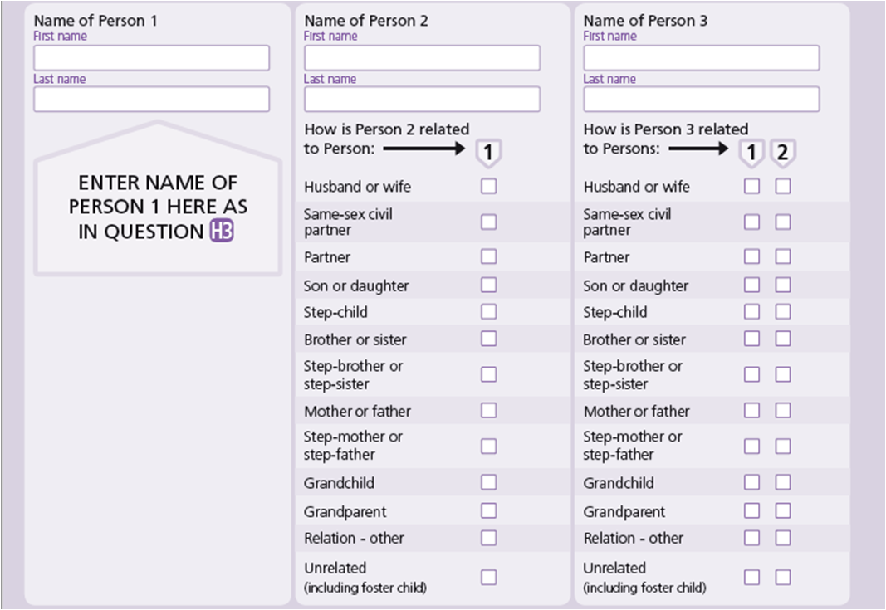
Despite conferring a clear advantage over the alternative approach of simply identifying the relationship of each person in the household to person 1, as used in previous censuses, there were drawbacks to this approach. For instance, the design of the relationship question was complex, spanning two pages of the questionnaire. Furthermore, households of more than 6 people had to ask for an extension form. The extended form also asked for an abbreviated response that differed from the standard question design. Ultimately, these complications had an impact on self-completion rates, resulting in relatively high imputation rates compared with other key variables. For example, relationship to person 1 was imputed statistically for 4.4% of records and deterministically for 0.8%. In comparison, the total imputation rates for age and sex were <1%.
Significantly, the complexity of the information collected through the relationship matrix also meant that the editing, imputation and QA of relationship information was more difficult than for other variables.
The main objective for the E&I process was therefore to resolve the relationship matrix captured on the census questionnaire so that it was consistent and met the requirements of the Household Composition Algorithm (HCA), which was used to identify families within households.

In order to produce the clean relationship information required by the HCA, a mixture of deterministic imputation in SAS and statistical imputation in CANCEIS was carried out.

The SAS algorithms were developed specifically to lessen the imputation burden on CANCEIS by helping to change miscoded inter-personal relationships and improve data quality (internal working group paper UKCEAIWG (10)12).

A number of conditions to invoke editing in the SAS relationship algorithms were specified. These are detailed in appendix 1 and include common response errors like parent/child relationships being recorded the wrong way round. These were included in the relationship algorithms rather than left to CANCEIS to impute in order to mitigate the risk of un-imputable households and boost the donor pool during statistical imputation. The relationship matrix posed a particular risk in this area because of the large number of edit rules and response errors relating to relationships, particularly in large households.

Only specific cases where there could be a high certainty of a response error were imputed deterministically in SAS and these were constrained by a number of conditions to further increase certainty. A review by the ESRC Centre for Population Change concluded that the proposed actions and associated constraints were appropriate and supported their use (internal working group paper UKCEAIWG (11)03).

A number of triangulation rules were also included in the SAS code to help impute missing relationships and further lessen the strain on CANCEIS e.g. where two people in a house shared one or more parents but were not recorded as siblings, their relationship was deterministically imputed to ‘sibling’ so that it did not have to be imputed by CANCEIS. This meant that CANCEIS only had to impute missing relationships where there was no information at all in the questionnaire. In testing, these triangulation rules were found to improve the edit rule pass rate for households in the demographics module in CANCEIS by about 3 percentage points overall and by about 8 percentage points for six person households. Application of deterministic relationship algorithms prior to statistical imputation was very effective in addressing the response errors in the relationship matrix and improving the ratio of donors to failed records.

Evaluation of the 2011 relationship matrix E&I strategy determined that it appeared to have been appropriate on the whole in meeting the aims and objectives for the 2011 Census - it was able to successfully impute the matrix to be used by the HCA under complex edit constraints, effectively address common response errors and improve the ratio of donors to failed records. Only a small number of issues were identified including the fact that some of the edit rules applied during E&I did not match up with the rules used in the HCA (e.g. a person was allowed to have multiple partners during imputation but not during the construction of family relationships in the HCA), which can be successfully resolved by cross-referencing the rules applied in these two processes.
It should also be noted that the SAS algorithm code is complex and will have to be updated to take into account any changes to census questions and the number of relationships captured on the census questionnaire in 2021, so it is recommended that the code must be carefully reviewed and quality assured again before application in 2021.

5.4.1 Recommendations
Given the absence of any major issues with application of the SAS relationship algorithms in 2011 and the benefits conferred by lessening the strain on CANCEIS by resolving common response errors, it is recommended that they are used once again in 2021 to deterministically resolve specific issues before data are processed by CANCEIS, but that they should be reviewed carefully before application to take into account changes since 2011 and to ensure that the rules applied meet the needs of the HCA.

6.0 Addressing changes since 2011

In addition to the work building on 2011, further research has also been undertaken to address emerging issues due to changes to the way data will be collected in 2021 and to take advantage of the availability of alternative data sources.

Since completion of the 2011 Census, and following a detailed research programme, the National Statistician recommended a predominantly online UK Census in 2021, supplemented by the use of administrative data. This was approved by the UK Government in July 2014. The ONS is now fully committed to the development of a different kind of Census in 2021. As such, exploring the impact that administration data and internet capture may have on the accuracy of imputation estimates are two important facets of that commitment.

6.1 Electronic data collection: Managing response mode bias

Previous research suggests that internet capture may have two promising features. It appears to yield data that has less non-response and more consistency than that captured through a paper questionnaire (e.g., Cote and Laroche, 2009). It also appears to attract respondents with characteristics often associated with those that are hard to count, such as working age males; higher levels of education; a professional occupation; a country of birth outside of the UK; a second home abroad (Ghee, 2014). In addition to having less data to impute overall, an increase in observed hard to count characteristics can only serve to reduce uncertainty in census population estimates usually associated with imputed data.

Despite these promising aspects, notable distributional differences in the characteristics of internet and paper based responders also suggest that when imputing mixed mode data using donor-based methodology it may be necessary to include mode as a matching variable in the underlying imputation model. Unspecified, there is risk of introducing a sampling bias into imputation estimates through randomly drawing a donor from a donor pool that is potentially heterogeneous. As sampling bias tends to be more likely with subsample size inequality, the higher rate of clean and consistent records in internet responses, coupled with a higher rate of records that need imputing in paper based responses, may serve to increase that risk.

Research has been carried out on 2011 census data directed at evaluating the differences between imputation estimates from a donor based imputation strategy that includes mode as a discrete matching variable compared to one that does not (Rogers et al., 2014). The 2011 Census demographics modules for four processing units from across the hard to count spectrum were imputed in CANCEIS under two conditions. In the controlled condition, donors could only be selected that responded through the same mode as the record being imputed. In the free condition, any donor could be selected, regardless of mode.
Differences in imputation estimates were measured by comparing the distributions of the imputed data obtained from each of the two imputation strategies. However, to ensure that any potential differences were not simply attributable to imputation variance, the data were imputed 10 times for each condition and comparisons were based on jackknife point and variance estimates of the imputed distributions over those 10 runs.

In general, there were small but systematic differences in distributions of imputed data for demographic and other variables that could not be explained away by imputation variance (net changes: approx 1% to 3.5%) and, generally, the ‘harder to count’ and area, the more prevalent the change. However, systematic differences were evident across all processing units and many of the census variables tested.

Table 2. highlights some of the largest differences in distributional estimates for each of the variables in the demographics module for the Central London processing unit.

Table 3. Highlights of distributional differences in imputation estimates
 |  | Controlled | Free | Difference
 |  | condition (%) | condition (%) | (%)
Age Group | 15 to 19 | 9.890 | 9.046 | -0.843
 | 20 to 34 | 29.292 | 30.802 | +1.510
 | 35 to 44 | 13.440 | 14.032 | +0.593
Sex | Female | 53.252 | 51.597 | -1.655
 | Male | 46.748 | 48.403 | +1.655
Country of birth | UK & Rep.Ireland | 51.062 | 49.956 | -1.106
 | NCR¹ | 19.916 | 21.182 | +1.270
Activity last week | Working | 36.205 | 36.903 | +0.698
Second address | Outside UK | 4.704 | 5.223 | +0.519
1 No Code Required: Student with term time address outside of UK

Compared to the imputation strategy that included mode in the imputation model, not controlling for mode led to higher imputation estimates for 20 to 44 year olds; males; and people who were working. The increase in estimates for the 20 to 44 age groups seemed largely to be at the expense of lower estimates for 15 to 19 year olds. Not controlling for mode also led to higher estimates for students living outside of the UK during term time and people with a second address outside of the UK. The increase in estimates for students living outside of the UK seemed mainly to be at the expense of lower estimates for people born in the UK or Republic of Ireland.

To put this into context, there were 152 more people with an activity last week of working in the free condition compared with the controlled condition in Central London. This is approximately equal to a postcode’s worth of individuals.

This seems to confirm that by not conditioning the imputation on mode the risk of introducing a small but systematic sampling bias into imputation estimates through randomly drawing a donor from a heterogeneous donor pool is likely to be realised.

6.1.1 Recommendations
While mode effects in 2011 were small so likely to have little impact on high level census estimates, there is a clear evidence of a systematic bias, with a risk of a greater impact at lower levels of aggregation due to the fact that non-response tends to cluster.

Furthermore, analysis was based on 2011 Census data and we cannot be sure what will happen in 2021 – i.e., a higher rate of internet capture in 2021 will increase the likelihood of a paper record having an online donor which may increase the magnitude of any biases.

Overall, therefore, the results of the current study therefore suggest that when imputing mixed mode data using donor-based methodology, particularly where respondents are free to choose their mode of response, it may indeed be important to consider including mode as a weighted matching variable in the underlying imputation model.

It is not recommended that response mode be used as an imputation class however (forcing donors to be from the same mode as recipients), due to the fact that this could significantly reduce the size of donor pools for paper responders, particularly large households, if paper response is particularly low in certain areas.

It is also recommended that we develop some diagnostics to check the 2021 data as it comes in so that options can be evaluated based on live data (e.g., consider London as an example of where a response mode bias is likely to be most evident) and to look for opportunities/research that provides us with some insight into modal biases in the 2021 Census data and what impact that might have on imputation so we can inform the early design of process. This could come from 2019 rehearsal data, other mixed mode surveys etc.

6.2 The use of administrative data as auxiliary information to support imputation of age

In line with the census design objective to make the best use of admin data in 2021 Census operations, a proof of concept study was conducted on the potential for using auxiliary information from lined admin data to support imputation of age.

Blum (2006) describes a number of mechanisms by which administrative records can aid the imputation process. These include cold-deck imputation, improving model specification, and continuous quality assurance. The first of these, cold-deck imputation, carries a risk that observed census data could be changed on the basis of inconsistent values obtained from an external administrative source. Given this risk and the uncertainty surrounding both the quality of available administrative sources and the linkage mechanism, our initial research has focused on the use of linked administrative data as an auxiliary variable within the conventional hot-deck approach already employed by ONS. There is comparatively little research available in this area since research tends to focus on using admin data to avoid the need for hot-deck imputation (e.g. Farber et al., 2005).

The aim of the research was therefore to determine whether linked administrative data could improve the accuracy of imputation estimates for age, what an improvement actually looks like, and to gain some insight into where different strategies fall on a continuum of accuracy, with a view to eventually establishing some general principles for the use and evaluation of administrative sources in the 2021 UK Census since, if we are to use admin data to aid imputation, we must be confident that it can improve the results compared with the conventional no admin data approach applied in the 2011 Census E&I methodological framework.

Age was used because this is a key census variable, is known to be of generally high quality in a number of admin datasets, and is likely to suffer time lag issues due to being derived from date of birth, making it an ideal candidate for preliminary investigations.
The first phase of the analysis focused on the predictive and distributional accuracy (Chambers, 2001) of the imputation estimates for one ‘typical’ Census delivery group that had age randomly perturbed for 5% of records and was imputed under the following conditions: no administrative data (2011 Census approach), synthetic exact administrative data, synthetic administrative data with +/-3 years error, synthetic administrative data with +/-6 years error, synthetic administrative data with +/-12 years error.
Demographic data for households containing 1 to 6 people were used, with the age variable imputed using the 2011 UK Census imputation model implemented in CANCEIS, which included the matching variables of: relationship to household person 1; sex; marital status; activity last week; student indicator, term-time address indicator; country of birth indicator; ‘hard to count’ rating; as well as the additional matching variable of ‘admin age’ provided by the synthetic administrative sources, with its weight set to equal that used for age in the 2011 Census. Admin age was set to equal the true census age for all clean records.
Figures 5a to e set out the distributions in the error of imputed age in each experimental condition, showing that the exact admin condition clearly performed better than the no admin condition, but where there was error in the admin data, this had a clear detrimental effect on imputation, producing bimodal distributions, directly reflecting the level of error in the admin data.
Figure 5. The distribution of error in imputed age by experimental condition

Figure 5a. Exact admin data Figure 5b. No admin data (standard imputation)
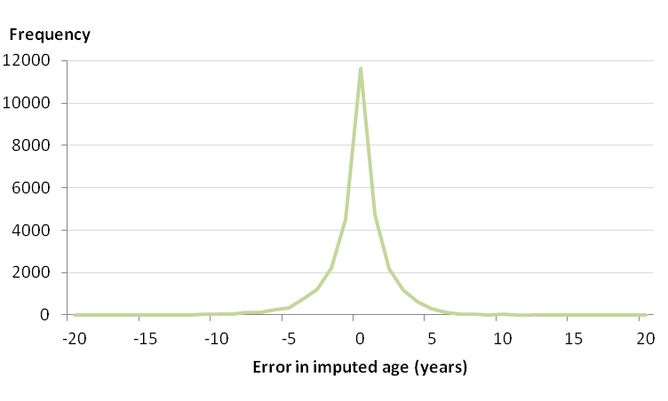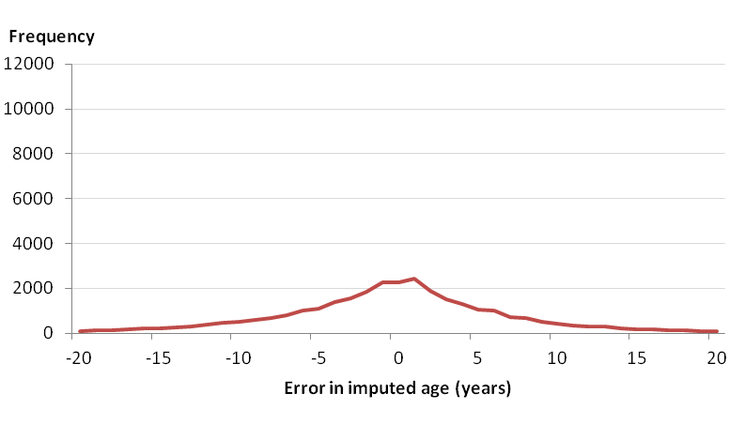

Figure 5c. +/- 3 years admin data error Figure 5d. +/- 6 years admin data error
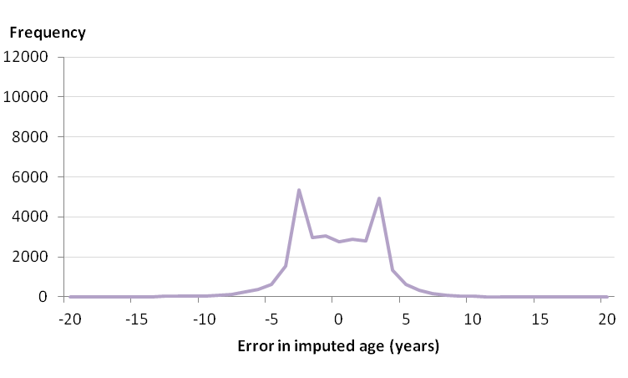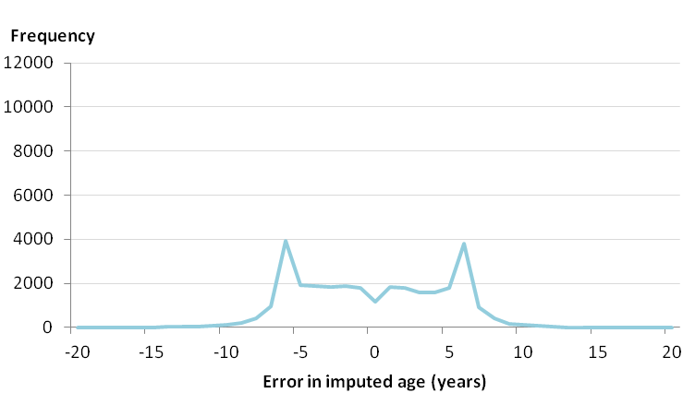
Figure 5e. +/- 12 years admin data error
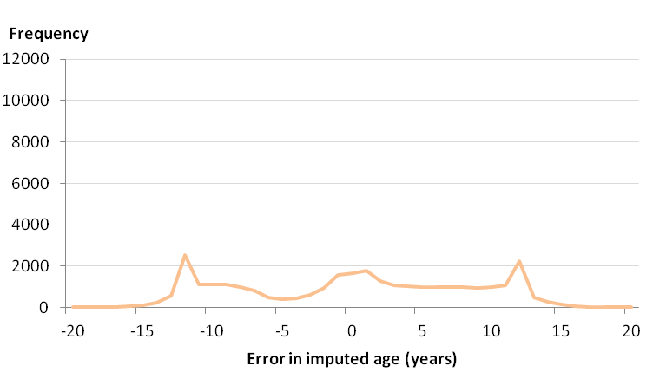

Distributional accuracy was also examined and the exact admin condition was found to be best able to recover the true age distribution of the data.

The erroneous admin data conditions on the other hand had poorer distributional accuracy compared with the no admin condition and had particular difficulty in recovering the true age distributions around the school age/working age boundary between 15 and 16 years old (which could not be accounted for by imputation variance) (Figures 6a to 6c).

Figure 6a. Age distribution of the households imputed using admin data +/-3 compared with the truth deck (+/- SD)
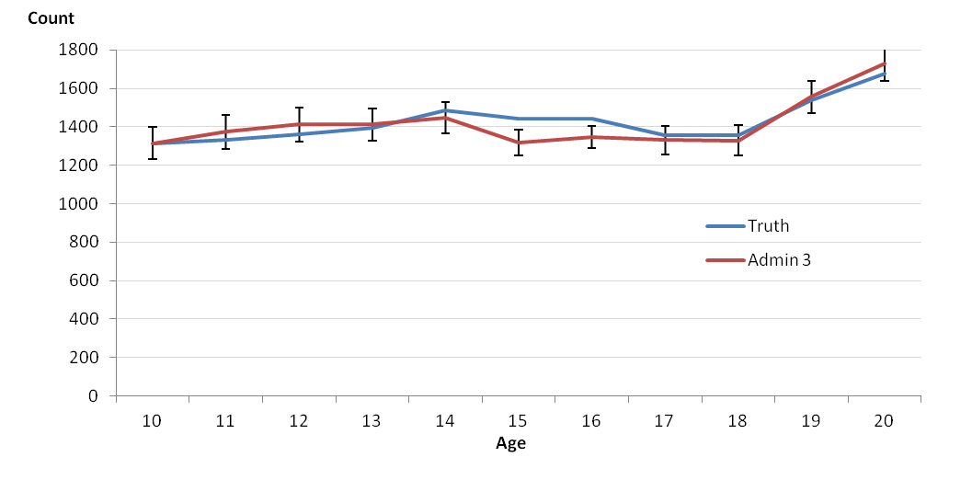
Figure 6b. Age distribution of the households imputed using admin data +/-6 compared with the truth deck (+/- SD)
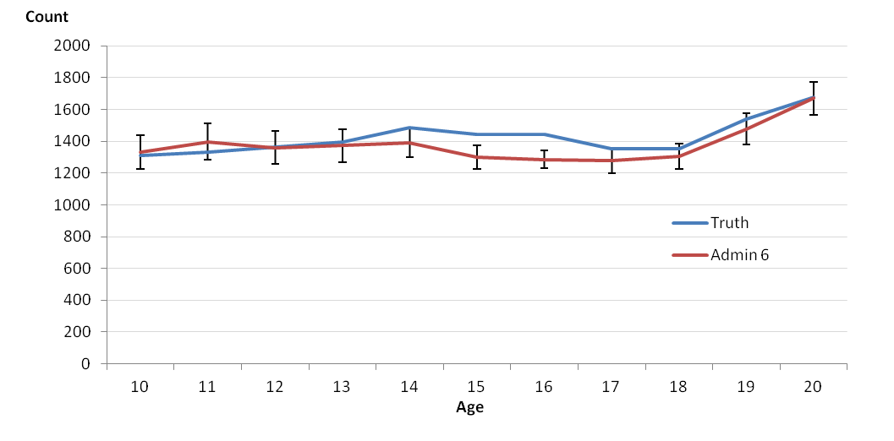
Figure 6c. Age distribution of the households imputed using admin data +/-12 compared with the truth deck (+/- SD)
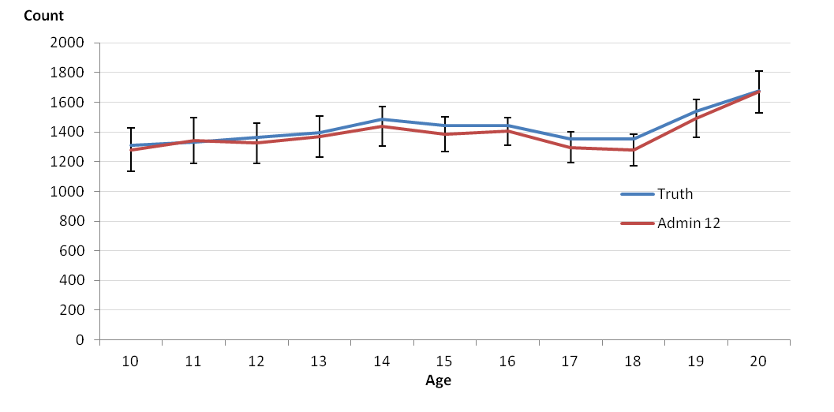

Further analysis of the post-imputation donor pool metrics revealed that these findings were driven by records with a true age on one side of the school-age/working-age boundary and an admin age on the other which caused difficulties during donor selection. Effectively, it reduced the number of potential donors with the correct true age entering the donor pool, thus also reducing the probability of the true age being recovered. In contrast, in the admin 12 condition, the error in the admin data was so large that CANCEIS was just not able to match closely on admin age while maintaining consistency with the rest of the observed data, meaning that the admin age was effectively ignored as a matching variable, making the system more likely to recover the true age using the rest of the matching variable set (as in the no admin condition).

Overall, the analyses of distributional accuracy demonstrate that relatively small but systematic errors in the admin data source are likely to lead to underestimates of the counts around the working age boundary. However, where there is so much error in the admin data that it becomes inconsistent with the observed data, the methodology in CANCEIS effectively protects the observed census data from these errors.

Once the general principles had been established, demonstrating what an improvement on the no admin approach looked like and the level of accuracy in the admin data needed to achieve that, the next phase of research focused on determining how two real admin datasets might perform in this context. This involved firstly analysing the error distributions of two actual administrative datasets, the NHS Patient Register (PR) and the Department for Work and Pensions’ Customer Information System (CIS), linked exactly to 2011 Census data by forename, surname, sex and postal code. The residuals from this process were then linked probabilistically. Where age was observed on the administrative source and the Census, both the PR and CIS datasets had over 98% exact agreement with the Census age for the exact matches, and over 85% agreement for the probabilistic matches, indicating high reliability of the age variable in these sources, although this did vary by age, with lower agreement at older ages in particular.
The observed error distributions from the PR and CIS datasets from both the exact and probabilistic matching exercises were then used to construct a further set of synthetic administrative datasets, which were used as auxiliary information in imputation of the perturbed dataset, in the same way as with the first phase of research.
Table 5 sets out the distributions of the error in the imputed age compared with the true age for the two conditions with error distributions based on the exact matches, compared with the exact administrative data and no administrative data conditions. Predictive accuracy was similar to that of the exact admin condition, which is to be expected given the high reliability of the age variable, clearly indicating that existing admin datasets are potentially able to deliver a substantial improvement on the conventional no admin data strategy.
Table 4. Summary statistics for the error in the imputed age compared with the true age for the CIS and PR synthetic conditions contrasted with the no admin data and exact admin data conditions
 | PR exact matches |  |  | CIS exact matches |  |  | Exact admin data |  |  | No admin data
 | Estimate | 95% CIs |  | Estimate | 95% CIs |  | Estimate | 95% CIs |  | Estimate | 95% CIs
Mean | 0.17 | 0.14 | 0.20 | 0.17 | 0.14 | 0.20 | -0.16 | -0.19 | -0.13 | -0.19 | -0.28 | -0.09
Std Dev | 2.67 | - | - | 2.68 | - | - | 2.56 | - | - | 8.44 | - | -
Variance | 7.15 | - | - | 7.19 | - | - | 6.54 | - | - | 71.27 | - | -

The distributional accuracy for both conditions was also higher than the no administrative data condition, with RMSE figures of 18.93 and 19.25 for the PR and CIS conditions respectively, compared with 19.82 for the no administrative data condition.
For all four of the synthetic PR and CIS datasets (both exact and probabilistic matches), the coverage levels were then systematically reduced to 80%, 60%, 40% and 20% (with 100% and 0% coverage having already been indirectly assessed at the earlier stages) by randomly applying the synthetic admin data error distribution to only the specified percentage of the perturbed records, and setting the remainder of cases to missing. The missing cases would therefore simply not provide any additional information when imputing missing age values in the census dataset.
As would be expected, the percentage of records recovering the true age decreased as the coverage level decreased, with only 15% recovery of the true age when coverage was 20%, compared with 37% recovery at 100% coverage.
Figure 7 presents the performance of the different experimental conditions on a continuum demonstrating where the real admin datasets might fall.
Figure 7. Expected imputation accuracy for age when conditioned on PR and/or CIS admin data with differing coverage levels relative to that for perfect admin data and a standard census

imputation method (no admin data)

Exact admin data
Mode = 0
38% recovery of true age
RMSE = 19

No admin data
Mode = 1
7% recovery of true age
RMSE = 20
+/-3 yr error in admin data
Bimodal error in imputed data
RMSE = 28

Worsening performance
PR and CIS – 100% coverage
Mode = 0
~37% recovery of true age

Standard performance
+/-6 yr error in admin data
Bimodal error in imputed data
RMSE > 30

Best performance
PR and CIS – 20% coverage
Mode = 0
~15% recovery of true age

80%
60%
40%

It is interesting to note that even at 20% admin data coverage the proportion of true age recovered for the PR and CIS conditions (15%) was more than twice that of the standard no admin condition (7%), suggesting that even with limited coverage there is still likely to be some improvement in imputation accuracy in an integrated census-admin data approach to E&I.
To put these findings into context, the matching exercise used to produce the synthetic datasets was analysed in a little more detail to give some indication of the actual coverage levels we might expect for both the CIS and PR datasets when linked to 2021 Census data. This indicated that if coverage of these admin datasets remains similar in 2021, it would be reasonable to expect coverage levels of around 60%.
Figure 8 illustrates the distribution of errors in imputed age using the PR and CIS exact match synthetic datasets assuming 60% coverage. The no admin error distribution had a standard deviation of 8.44 compared with 4.65 and 4.63 for the CIS and PR error distributions, respectively. Also, just over 7% of imputation actions had an error of 0 years in the no admin condition, compared with approximately 27% for both the PR and CIS conditions, illustrating that the admin data conferred clear benefits at this level of coverage.

Figure 8. Distribution of errors in the imputed age for the PR and CIS synthetic imputations assuming 60% coverage
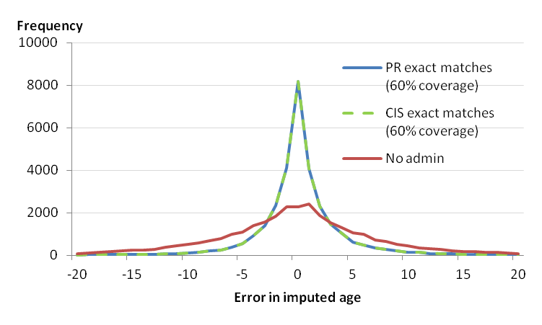
The results show that it is possible for administrative data to substantially improve the accuracy of imputation estimates for age in the census under certain conditions and that existing administrative datasets appear to be of sufficiently high quality to potentially deliver this improvement. The nearest neighbour minimum change methodology implemented in CANCEIS also ensured that, where the administrative data was so erroneous as to be inconsistent with the observed data, consistency was maintained over matching closely on the admin age variable. This effectively protected the observed census data from high levels of error in the administrative data, demonstrating a possible advantage over alternative direct substitution methods.
In terms of the impact of this on census estimates, this is however unlikely to have an observable effect on higher level aggregates due to low levels of missingness of age (just 0.8% in 2011), but there could be important gains for small area estimates since missingness of age has been observed to vary considerably at the OA level (exceeding 10% for some OAs in 2011). Here, imputation variance associated with traditional, no admin imputation is likely to be a more significant risk with respect to the accuracy of the estimates. This is a key area for stakeholders and users who are keen for accurate estimates at lower levels of geography (down to street level).
Age is a key routing variable in the census questionnaire and the most important variable in assessing the consistency between census variables. Consequently, any improvement in imputation accuracy for age could also confer improvements to the imputation of all its dependent variables. This will be particularly useful when imputing the more difficult census variables such as the labour market variables and the relationship matrix. Age is also extremely significant when imputing routing associated with the school-age/working-age boundary. This was particularly difficult in the 2011 Census where seemingly small factors linked to the imputation parameters for age had profound effects on the accuracy of census estimates (i.e., the 2011 Census 15 year old spike as discussed in section XX).

6.2.1 Recommendations
Given what this research has established in terms of proof of concept of the method, there appears to be value in implementing this method in 2021.

If we do proceed with implementation, however, further work will need to focus on the following areas, which require resolution before the method can be applied within the existing E&I strategy:

- Determining the best way to derive and incorporate the admin age variable (including considerations around data linkage) and evaluate the effects of this on imputation variance, multivariate imputation and the modularisation strategy (as the method may necessitate age being imputed on its own before other variables). In particular, the costs of implementing the strategy within the existing framework relative to the benefits gained for age will need to be assessed.
- Refining the method using real linked admin-census datasets, including exploration of the weighting and parameterisation within CANCEIS. The weighting in particular will have a large effect on how closely the system will match on admin age so it is important to optimise this.
- Development of diagnostic tools which can be used to evaluate different admin sources and integration of these into the end to end imputation system. This will also involve validation of the assumptions e.g. that the error where age is observed on both the census and admin source is a valid proxy for the error in the admin data when age is not observed on the census, and exploration of the variables that explain coverage and error of the admin data.
- Consideration of practical implications around admin dataset currency and time lag issues.
- Additional benefits may be gained from using linked census-admin data to explore patterns of non-response (dependent on suitable environment to carry out the work) – i.e. for records where census age is missing, what is the distribution of the admin age? This information could be used to aid development of the overall imputation strategy.

We must also acknowledge that application of the method will depend on the availability and quality of linked admin data during census processing.

7.0 Remaining research priorities

Given the research already completed, and the limited time before 2021, a number of remaining high priority areas to focus on before 2021 have been identified:

7.1 Implementation of admin data as auxiliary information to support imputation of age

As described in section 6.2, further work following on from the proof of concept will be required in order to implement the approach successfully in 2021.

7.2 Travel to work issues
Analysis on unusual travel to work combinations has been conducted on 2011 Census data and both the edit and imputation and record swapping stages have been found to contribute to increases in unusual combinations, including:
- Journeys likely to take more than an hour e.g.
  - Bicycle journeys over 20km
  - On foot journeys over 5km
- Combinations where the percentage of distance travelled was less than 1% in the observed data:
  - Underground, metro, light rail or tram over 40km
  - Bus, minibus or coach over 30km
  - Taxi over 30km
While these unusual combinations only account for the minority of journeys for each method of travel and the effect on the standards tables may be minimal, they may have a bigger impact on the Origin-Destination tables. As such, further research is therefore required to identify whether mitigating actions are required and how they should be implemented. (e.g. individual fixes during each process or as a single fix etc.)
7.3 The overall process flow
Further work is required on specifying the detailed E&I process flow, including implementing the batched, modularised approach to imputation. This work should take into account the aim to produce outputs earlier than in 2011 and address lessons learned during the evaluation e.g. the need to have flexibility for adding data-driven deterministic edits prior to imputation.
Furthermore, the evaluation recommended that E&I would benefit from an iterative design and testing approach with strong feedback loops and flexibility to make changes to the methods during live operations. The period for tuning and parameterisation should also be adequately planned and timetabled as the time this takes was underestimated in 2011.

7.4 Development of QA/diagnostics tools
In 2011, imputation diagnostics were limited to univariate analysis. Here, pre- and post-imputation distributions were compared. Further work will investigate whether new methods of univariate evaluation should be incorporated into the diagnostics.
Furthermore, the retention of multivariate relationships following imputation was not previously considered. Therefore, a second aim will be to investigate different possible methods of determining whether the current census E&I methodology robustly retains multivariate relationships in the data.

7.5 Imputation variance
The census E&I strategy follows a single imputation approach. This meets the need of users for a single complete and consistent census database from which to produce a range of cross-tabulated outputs. However, it introduces a risk in that users simply treat all values as ‘observed’ and do not take into account the uncertainty in the imputations. As such, and in line with the overall E&I principles presented in section 4.3, further work will be conducted on producing estimates of imputation variance to be disseminated in public-facing outputs to ensure that users understand the uncertainty introduced at each stage of statistical processing.

The work will aim to calculate the variance of the domain totals generated by the imputation system.
Nearest neighbour imputation methods are often deterministic; finding only one optimal donor per failed record. The CANCEIS donor search method is also deterministic up until the point of constructing the final list of near optimal donors, from which the actual imputation action is selected at random. Therefore, only the variations between the imputation actions on the final donor list need to be considered to deduce the variance introduced by the imputation process.
For imputation strategies where the donor pool is fixed and donor selection probabilities are known, it is possible to calculate the imputation variance with little computational effort. When the donor pool is not fixed, such as with a modular imputation method as applied during the census (where the construction of the donor list in the current module will depend on the imputed values from the previous module), the conditional variance becomes complex to calculate for large imputation problems due to the vast number of possible donor pool combinations generated from each module. It may therefore be possible to use a Monte Carlo simulation method to generate approximations of the expectation and variance through sampling techniques. However, depending on the simulation design and the imputation method, repeated runs can still become cumbersome and computationally intensive e.g. to generate a variance estimate for all modules for the entire census population, the Monte Carlo simulation would have to be applied to all the geographical sub-groups of the data which may not be feasible in the census. Research will therefore need to be undertaken to investigate possible techniques for scaling up from a sample. Potential methods include a sample scheme for selecting the Monte Carlo areas, the use of generalised variance functions and the application of regression techniques.

8.0 References

ABS (2016). Census of Population and Housing: Census Dictionary, 2016. Available online: [10/01/2019] http://www.abs.gov.au/ausstats/abs@.nsf/Lookup/2901.0Chapter29102016

Aldrich, S., Wardman, L., and Rogers, S. (2012). The practical implementation of the 2011 UK Census imputation methodology. Proceedings of the UNEC Conference of European Statistics. Norway, 2012.

Andridge, R. R. and Little, R. J. A. (2010). A Review of Hot Deck Imputation for Survey Non-response. International Statistical Review, 78: 40–64.

Bankier, M. (1991). “Alternative method of doing quantitative variable imputation”, Statistics Canada Memorandum.

Bankier, M. (2000). 2001 Canadian Census minimum change donor imputation methodology. Proceedings of the UNEC Conference of European Statistics. Wales, 2000.

Bankier, M. (2011). Imputing numeric and qualitative variables simultaneously. A Technical Report Detailing the Methodology of CANCEIS, Internal report, Statistics Canada.

Bankier, M., Lachance, M., and Poirier, P. (1999). A Generic implementation of the nearest neighbour imputation method. Proceedings of the Survey Research Methods Section. American Statistical Association, 548-553.

Bankier, M., Poirier, P., and Lachance, M. (2001). Efficient methodology within the Canadian Census edit and imputation system (CANCEIS). ASA Joint Statistical Meetings, Atlanta.

Blum, O. (2006). Evaluation of editing and imputation supported by administrative records. Statistical Data Editing Volume 3: Impact on Data Quality, UNECE, pp300-309. Available online [10/12/2015] http://www.unece.org/stats/publications/editing/SDE3.html

Canceis, (2009). CANCEIS V4.5 User Guide. CANCEIS Research & Development Team. Statistics Canada.

Canceis, (2015). CANCEIS V5.2 User Guide. CANCEIS Research & Development Team. Statistics Canada.

Chambers (2001), “National Statistics Methodological Series Report 28: Evaluation criteria for statistical editing and imputation”, Office for National Statistics.
Cote, A-M., and Laroche, D. (2009). The internet: A new collection method for the Census. Available online: [06/01/2015] http://www.statcan.gc.ca/pub/11-522-x/2008000/article/10986-eng.pdf

De Waal, T., Pannekoek, j., and Schotus, S. (2011). Handbook of statistical editing and imputation. Wiley, New Jersey.

Dial, S., Enriquez, J., Moore, B., and Mosina, S. (2014). Comparison of alternative imputation methods in the national teacher and principal survey. JSM 2014 - Survey Research Methods Section.

Durrant, G. (2005). Imputation methods for handling non-response in the social sciences. A Methodological Review. NCRM Methods Review Papers /002, University of Southampton.

Farber, J., Wagner, D., and Resnick, D. (2005). Using administrative records for imputation in the Decennial Census, ASA Section on Survey Research Methods.

Fellegi, I.P., and Holt, D. (1976). A systematic approach to automatic edit and imputation. Journal of the American Statistical Association, March 1976, Volume 71, No. 353, 17-35.

Ghee, K. (2014). Internet versus paper mode effects in the 2011 Census of England and Wales: Analysis of Census Quality Survey agreement rates. Available online: [06/01/2015] http://www.unece.org/stats/documents/2014.09.census1.html#/http://www.unece.org/stats/documents/2014.09.census1.html#/

Guertin. L., Bureau. M., & Morel, J. (2014). Editing the 2011 Census data with CANCEIS and options considered for 2016. Proceedings of the UNEC Conference of European Statistics, France, 2014.

Kamen, C. (2005). The 2008 Israel integrated census of population and housing basic conception and procedure. Central Bureau of Statistics, Israel.

Leather, F., Sharp, K., & Rogers, S. (2016a). Towards an integrated census-administrative approach to item-level imputation for the 2021 UK Census. Proceedings of the 2016 Statistics Canada Methodology Symposium, Canada, 2016.

Leather, F., Sharp, K., & Rogers, S. (2016b). The 2011 UK Census 15 year old age spike imputation issue: Causes and solutions. ONS Technical Report. Presented to the 2021 UK Census Research Advisory Group, July 2016.

Leather, F., Sharp, K., & Rogers, S. (2016c). CANCEIS donor search optimisation: A two stage approach. ONS Technical Report. Ways to improve the statistical performance of CANCEIS in the 2021 UK Census, currently unreleased, August, 2016.

Liu, C., Crowe, S., and Alavi, A. (2011). How does CANCEIS work & can it benefit more users?. Proceedings of the Statistics Canada Methodology Symposium. Canada 2011.

Office for National Statistics (2012). Item Edit and Imputation: Evaluation Report. 2011 Census: Review and Evaluation. Available online: [23/01/2019] http://www.ons.gov.uk/ons/guide-method/census/2011/how-our-census-works/how-did-we-do-in-2011-/evaluation---item-edit-and-imputation.pdf

Office for National Statistics (2015). 2021 Census Design Document. Available online: [30/01/2019]: https://www.ons.gov.uk/ons/guide-method/census/2021-census/progress-and-development/research-projects/2021-census-design-document.pdf

Rogers, S., Dyer, L., & Foley, B. (2014). Towards the 2021 UK Census imputation strategy: Response mode as a matching variable in a donor-based approach? Proceedings of the 2014 Statistics Canada Methodology Symposium, Canada, 2014.

Rogers, S., Leather, F., & Sharp, K. (2017). Proposal for using CANCEIS in the 2021 Census imputation Strategy. ONS technical report. Approved: CRAG, DAG, and DA March 2017. Available on request.

Statistics South Africa (2011). 2011 Census Data Quality report. Available online: [10/01/19] http://www.statssa.gov.za/census/census_2011/census_products/Data_quality_report_Final_12%20November.pdf
Stats NZ (2006). Imputation and Balancing Methodologies for the 2006 Census. Available online: [10/01/2019] http://archive.stats.govt.nz/Census/about-2006-census/methodology-papers/imputation-and-balancing-methodologies-for-the-2006-census.aspx

UNECE (2006). Statistical data editing vol. 3: Impact on quality. UNECE.

UNECE (2016). High-Level Group for the Modernisation of Official Statistics / Modernisation Committee on Production and Methods. CANCEIS. Available online: [18/02/2016] http://www1.unece.org/stat/platform/display/MCOPM/MC+on+Production+and+Methods%3A+Home

United Nations Statistics Division (2011). Report on the Results of a Survey on Census Methods used by Countries in the 2010 Census Round. UN. Available online: [10/01/2019] https://unstats.un.org/unsd/censuskb20/KnowledgebaseArticle10696.aspx

United Nations Statistics Division (2011). UN Handbook on Population and Household Census Editing, Revision 1. UN.

Wagstaff, H., & Rogers, S. (2006). An application of CANCEIS on 2001 Census Data. ONS Technical Report.

Wardman, L., Aldrich, S., and Rogers, S. (2012). Item imputation of 2011 Census data in an automated production environment; advantages, disadvantages and diagnostics. Proceedings of the UNEC Conference of European Statistics, Norway, 2012.

Wardman, L., Aldrich, S., and Rogers, S. (2014). 2011 Census item edit and imputation process. Available online: [18/02/2016] http://www.ons.gov.uk/ons/guide-method/census/2011/census-data/2011-census-user-guide/quality-and-methods/quality/quality-measures/response-and-imputation-rates/item-edit-and-imputation-process.pdf

Winkler, W., & Chen, B-C. (2001). Extending the Fellegi-Holt model of statistical data editing. Research Report Series. U.S. Bureau of the Census

Zadka, P., and Fienstien, Y (2012). The 2008 integrated census in Israel and future censuses. United Nations International Seminar on Population and Housing Censuses.

Appendix 1 – Edit constraints applied by the relationship algorithms for the 2011 Census

Relationship algorithm 1 conditions were as follows.

