

Background

Provisional Accredited Researcher
Application Guidance
The following legal gateways allow accredited and approved researchers to access data for research and statistical purposes. The Digital Economy Act 2017 (DEA) (Part 5, Chapter 5) includes an important statutory framework to support the UK research community, both within government and beyond, that permits public authorities to share de-identified information with accredited researchers for the purposes of public good research. The Statistics and Registration Service Act (SRSA) 2007 at s.39(4)(i) allows access to unpublished data held by the Office of National Statistics by approved researchers for the purpose of statistical research.

Both gateways aim to broaden the capacity of research to deliver direct and indirect public benefits, including the production of valuable new research insights about UK society and the economy. All projects involving access to data for research purposes using the SRSA Approved Researcher gateway and the DEA Research power will be consistently accredited using the Research Code of Practice and Accreditation Criteria.

The Code also sets out the criteria for the accreditation of processors, research projects and researchers and the Authority has established the Research Accreditation Panel (RAP) to independently accredit each of these.

Researcher Accreditation

There are two different types of individual accreditation; Full Researcher or Provisional Researcher.
To be an Accredited Researcher, an individual must meet the following criteria:

1. Have an undergraduate degree (or higher) including a significant proportion of maths or statistics, or be able to demonstrate at least 3 years quantitative research experience; and
2. Have successfully completed a Safe Researcher training course run by ONS, or another equivalent course which has been recognised by ONS such as is run by the UK Data Service, the Administrative Data Research UK partners, or HM Revenue and Customs (HMRC);
- Agree to their inclusion in a list of all Accredited Researchers, published on the UK Statistics Authority website;
- Agree to publish the results of all Accredited Research projects completed as an Accredited Researcher; and,
- Sign and adhere to a formal Accredited Researcher Declaration.

Individuals who do not meet the academic qualifications or research experience criteria to be a Full Accredited Researcher (AR), but who have been asked to contribute to an Accredited Research project led by a Accredited Researcher, may be granted Provisional Accredited Researcher status, subject to meeting the following criteria:
  - The applicant must have successfully completed a Safe Researcher training course run by ONS, or another equivalent approved course such as those run by the UK Data Service, the Administrative Data Research UK partners or HMRC;

  - The applicant must agree to their inclusion in a list of all Accredited Researchers published on the UK Statistics Authority website;

  - The applicant may only work on projects with the supervising Accredited Researcher;

  - An Accredited Researcher must agree to direct, supervise and take responsibility for all work undertaken by the applicant and support their application;

  - An Accredited Researcher must agree to publish the results of all research projects completed by the Provisional Accredited Researcher;

  - The application must explain how the individual’s skills will contribute to any research projects they work on;

  - Both the applicant and the supervising Accredited Researcher must work for the same organisation; and

  - Both the applicant and the Accredited Researcher must sign and adhere to the Provisional Accredited Researcher Declaration.

Application Process
Applications should be submitted via the Research Accreditation Service online portal. Once the application has been received, you will be sent a confirmation via email. The application will be reviewed by the team to ensure that all relevant fields are completed and for an initial assessment.
The Research Support team will contact you with details of how to book onto the Safe Researcher training offered by ONS or another approved training provider, e.g. UK Data Service. We advise researchers to book training as soon as possible to avoid any potential delays to the application. Ordinarily, we see bookings made within two weeks of the communication for available dates.
Once you have successfully completed the training, you will need to sign a Provisional Accredited Researcher declaration, if you have not already done so with your application. Your supervisor will also need to sign the declaration.
Following completion of the training course, you will need to take and pass the training assessment. Once this is successfully completed, your application will be submitted to the SRS Customer Support for consideration. Subject to their approval, we will confirm your accreditation and provide you with an AR number. Your details will subsequently be published on the UK Statistics Authority website, along with details of your supervisor, and your research projects/exploratory analysis, in the public record of Accredited Researchers.
This accreditation will last for a period of three years

Completing the application form
All sections must be completed.

Your Details

These details will be used to contact you, and to confirm your identity when you attend an approved training course, (e.g. Safe Researcher Training) or access data at a safe setting

provided by a Accredited Processor (a list of these will be published on the UK Statistics Authority’s website), to carry out your research.

If you work for more than one organisation, please complete this section providing details of your primary employer.

Please provide your work address, telephone number and email address rather than private details. If you are applying for researcher accreditation in a private capacity, please write ‘none’ for your organisation in section 2 and we will use your personal contact details.

Individuals based overseas can apply to become Accredited Researchers, but any projects must be undertaken within a UK based secure environment DEA and must deliver a public good to the UK.

Your organisation Details

Enter details here if you are applying to be a Provisional Accredited Researcher in connection with work you do for an organisation. If you are applying for researcher accreditation in a private capacity, please just write ‘none’.

Qualifications

Under the criteria to be granted Provisional Researcher Accreditation, you do not need to have a relevant undergraduate degree that includes a significant proportion of statistics or maths.
However, if you have any qualifications that demonstrate your ability to contribute to any research projects that you may work on, you should include details of these to support your application including any relevant experience of carrying out quantitative data research.

Research Experience (sections 4 – 6)

Under the criteria to be granted Provisional Researcher Accreditation, you do not need to demonstrate three or more years experience of analysing data for statistical research.

However, if you do have some relevant experience, you should include details of this to support your application. This would also help to demonstrate that you are working towards full researcher accreditation.

Note: to place an ‘x’ into the available check boxes, please double click on the box and select ‘checked’ under the Default Values heading in the menu that appears. To save your changes and close the menu, click ‘OK’.

Information to Support Application

This information could include other qualifications or experience you feel will support your application for accreditation. If your role is not purely analytical or statistical (e.g. data cleaning), the details can be included here.

Transparency

The UK Statistics Authority requires that Accredited Researchers and their projects are included in a public record and that the project results are published. The record will also include the details of the relevant supervisor for each Provisional Accredited Researcher. The UK Statistics Authority will only grant exemptions in exceptional circumstances.

Each request for an exemption will be considered by the Research Accreditation Panel (RAP). If the Panel decline the request, you will be given the option to withdraw your application.

Note: to place an ‘x’ into the available check boxes, please double click on the box and select ‘checked’ under the Default Values heading in the menu that appears. To save your changes and close the menu, click ‘OK’.

Supervisor Details (and section 10)

To be completed by the Supervising Accredited Researcher
These details will be used to enable us to link the supervisor to the record of Accredited Researchers.

11 Applicant Skills`
To be completed by the Supervising Accredited Researcher
Please include details of the applicant’s skills and experience that are relevant to the work they will carry out supporting you on research projects.

Submitting your application
Once completed, please return this application to your associated accredited data processing environment.

UK Statistics Authority

Yes

Accredited Researcher Application Process

Provisjonal AR

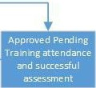

•
.


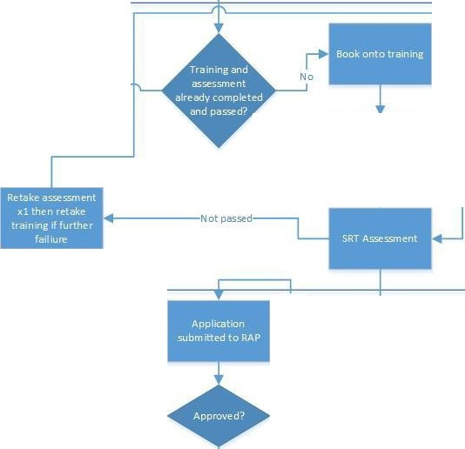
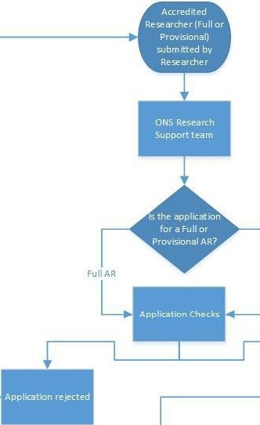
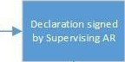
Passed--

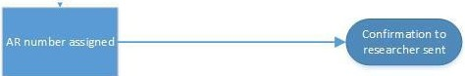
Yes

